OudhTrade
Backend Technical Design
Module 3 — Roles, Profiles & Verification · M03-3
Document details
Company | MRIDA INFRA AND PLANTATIONS LLP
Product | OudhTrade — oudhtrade.com
Document | M03-3 Backend Technical Design
Module | M03 Roles, Profiles & Verification (release R1; some items R2)
Readers | Backend developers, DevOps, tech lead
Related documents | PRD (PRD-ROL, PRD-IDN) · HLD · NFR · M02 · other M03 documents
Owner | Tech lead
Decision owner | T. Satish Reddy, CEO & Founder
Status | Draft for review — 24 September 2026
Classification | Confidential — for partners and the OudhTrade team

Contents
1. Overview 2
1.1 Services 3
1.2 Supplier adapters 5
1.3 What is stored where 6
2. Main Flows 6
2.1 Profile creation and landing on the dashboard 6
2.2 Business details with registry check 7
2.3 Identity check routes 8
2.4 Document submission 9
2.5 Review, decision and the publishing gate 10
2.6 Verification states 12
2.7 Expiry, grace and renewal 12
2.8 Re-verification 12
2.9 Role change 13
2.10 Farmer routes A and B, including offline agent forms 15
2.11 Farm visit 16
2.12 FPO confirmation 16
2.13 Agent and FPO quality re-checks 17
2.14 Enhanced check 17
2.15 Store name change 17
2.16 Setup card computation 18
2.17 Link ownership check 18
2.18 GST registered badge, capability and location details 19
2.19 Other documents and checklist growth 19
2.20 Away mode (R3) 19
2.21 Staff-awarded badges 20
3. Internal Interfaces 20
4. Public API Endpoints (v1) 21
4.1 Public 21
4.2 Profile, dashboard and setup 22
4.3 Business details and locations 23
4.4 Verification, identity and enhanced check 23
4.5 Farmers, FPOs and field agents 24
4.6 Staff (Admin app) 25
5. Events 27
5.1 Events Module 3 publishes 27
5.2 Events Module 3 reacts to 28
6. Jobs and Schedules 28
7. Security Design 30
7.1 Permission matrix 31
8. Configuration 32
9. Monitoring and Funnel Measures 34
10. Threat Model (STRIDE) 35

1. Overview
Module 3 is a set of services inside the Core API and the workers (HLD Section 4) that own the `profile` schema (35 tables, M03-5). They decide what each account is (role and profile), how far it can be trusted (verification state, badges, enhanced check) and what the public sees about it (trust section). Other modules never read the profile tables; they call the interfaces in Section 3 and react to the events in Section 5. Supplier calls (registry, DigiLocker, UIDAI e-KYC, selfie and liveness, bank check, sanctions service in R2) go through adapters inside Module 3 (HLD Section 8). The backend language and framework follow the team’s approved technology proposal (HLD 13.2). Rule IDs such as BUS-004 are M03-2 requirements (M03-FR-BUS-004).
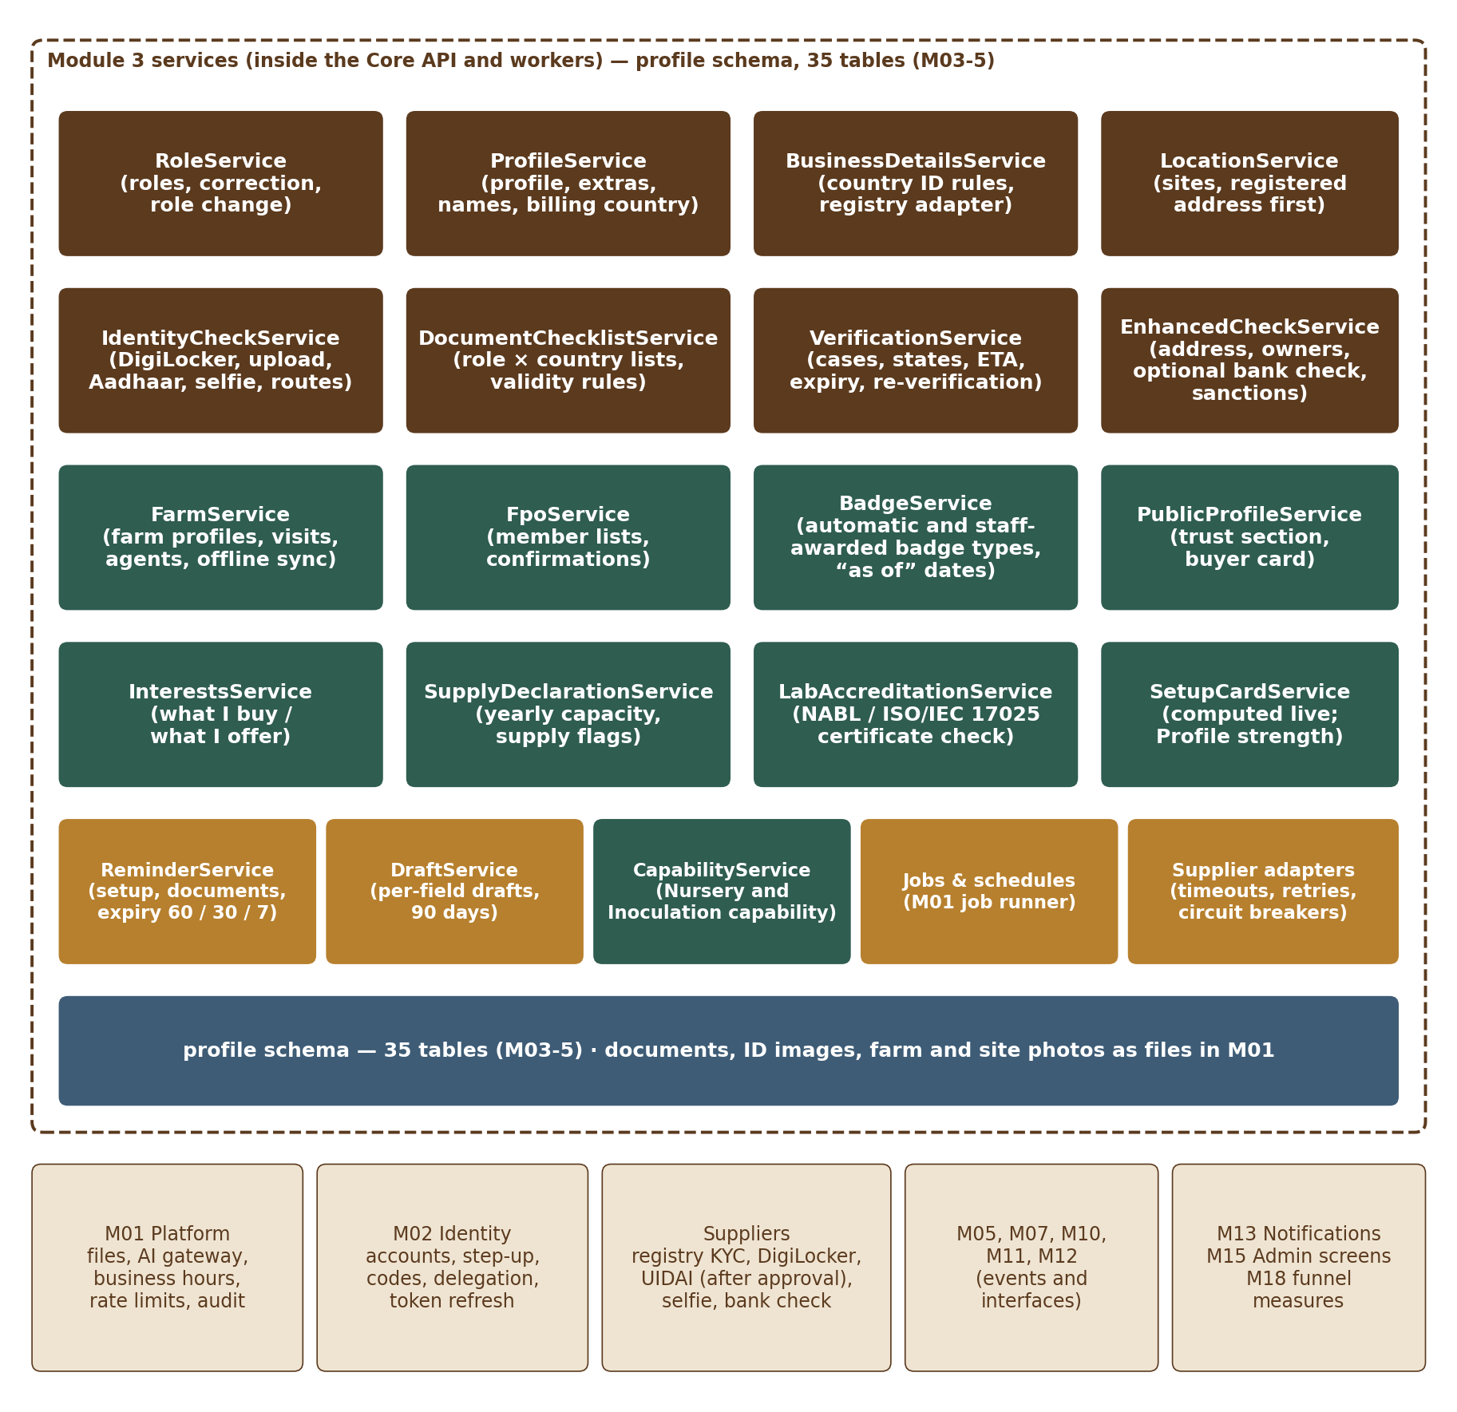
Figure 1 — Module 3 services

1.1 Services
Service | Responsibility | Runs in
RoleService | Roles and profile kinds (ROL-001), server check of role and of the roles an invitation allows (only when the user joined through one; sign-up is open to everyone), role correction before the first submission (ROL-006), role change requests and decisions (ROL-009 to ROL-016) with the allowed upgrade paths from the setting profile.role_change.paths (ROL-010), the combined buyer → selling role case with Moderator recommendation and Admin decision (ROL-017), Buyer Individual → Business self-service, “also active as” (ROL-008) | API
ProfileService | Profile creation on account.created (idempotent, ROL-004), profile extras, short bio and display name (PRF-014, PRF-015), languages, photos, translations, store (trading) name changes and name history (PRF-011 to PRF-013), billing country and its lock (TRS-009 to TRS-011), public visibility from account and verification state (PRF-003), away mode (PRF-018; planned release: R3) and the “My profile” own view with its section locks and the re-check warning (PRF-019, PRF-020) | API + worker
BusinessDetailsService | The three business-details steps (BUS-001 to BUS-019): country of registration, per-country ID fields from country_id_rules with format and check-digit rules, registry adapter (look-up, auto-fill, status rules, retries, monthly re-check), legal form, legal and trading names, name matching with the private name-mismatch note, authorised person, compliance declaration, duplicate registration flag, IEC and issuing authority (BUS-020 to BUS-022) | API + worker
LocationService | Business locations (LOC-001 to LOC-010): registered address as first site, types and site labels, primary site, private address and public city or district, contact hours, site photos and video (public after the M01 safety review), private home addresses of farmers and buyers, last-location rule | API
IdentityCheckService | Identity routes (IDV-001 to IDV-015): DigiLocker, uploaded ID, Aadhaar OTP e-KYC through a UIDAI-licensed provider (only after OVSE approval, behind a feature switch), selfie and liveness through the supplier’s live-camera component, selfie skip rules, remote selfie link, video-call and field-agent alternatives, “Continue on your phone” hand-off, Aadhaar refusal rules, adult confirmation | API + worker
DocumentChecklistService | Document lists per role category and country with the fallback and state rules (DOC-001 to DOC-006); the Document type dropdown and the “You need” list of the Documents step (DOC-029); the “Other document” option and the report of frequent “Other” names that grows the lists (DOC-027, DOC-028); publish-time checks that a country list only adds to the basic set | API + worker
VerificationService | Verification cases and the eight states (VER-001 to VER-018), document upload metadata and review decisions (DOC-007 to DOC-025), dated ETA and pause, escalation, fast lane, reviewer questions, rejection counting and senior review, expiry and 30-day grace, renewals, monthly registry re-check outcome, re-verification, publishing gate, AI translation for reviewers through the M01 AI gateway with ID and document numbers removed, watermarked viewer sessions | API + worker
EnhancedCheckService | Enhanced check (ENH-001 to ENH-008): address proof, owners 25 %+, the optional bank check (India automated through the bank check adapter; other countries a statement or bank letter for manual review), weekly manual sanctions batch in R1, automated sanctions and PEP screening in R2, holds on possible matches | API + worker
FarmService | Farmer profile and the optional, self-declared “Your trees” (FRM-001 to FRM-004, FRM-021), route A (ID check) and route B (field agent) (FRM-005 to FRM-007), farm visits and the Farm visited badge (FRM-009 to FRM-011), field agents, offline sync with idempotency keys, agent reassignment, 10 % quality re-checks (FRM-012 to FRM-015) | API + worker
FpoService | FPO member lists, matching, FPO and farmer confirmations, membership end and 90-day badge grace, invitations to FPOs not yet on OudhTrade (FRM-016 to FRM-020) | API + worker
InterestsService | What I buy / what I offer (BUY-001, BUY-005, PRF-006); the top-level categories from the Module 4 taxonomy (six today), and M04 sub-categories when M04 adds them; read by M07 and M08 | API
PublicProfileService | Trust section facts for the storefront (PRF-001 to PRF-004), buyer card for enquiries (BUY-002), “verified only” signal, links with their safety scans and ownership check (PRF-009, PRF-010, PRF-016) | API + worker
BadgeService | Badge types from badge_types: the 12 automatic badges with “as of” dates, re-checking status, removal rules (TRS-001 to TRS-005); GST registered from the registry check (TRS-012); Trusted given or removed when M10 asks (TRS-013, R2); staff-awarded badge types with the second-approver rule and the banned-word check, applications and awards (TRS-016); every change sends badge.changed | API + worker
SupplyDeclarationService | Declared yearly supply and source (TRS-006) — a Required setup-card item for sellers whose offer interests include wood, chips or oil, checked before their first wood, chips or oil listing is published — and the nightly comparison with visited trees and the export-quota share; supply.flagged (TRS-007) | API + worker
LabAccreditationService | NABL or ISO/IEC 17025 certificate, scope and expiry check before the “Accredited lab” badge (TRS-008) | API
SetupCardService | “Finish setting up” card, the next unfinished wizard step for “Continue setup” (DSH-017) and the “Make your profile stronger” card (DSH-018), computed live from the item table in M03-2 Section 3.2 (DSH-010 to DSH-015); stores only setup_completed_at and setup_dismissed_items (buyer “Not now” items); dashboard data (DSH-001 to DSH-009) | API
ReminderService | Onboarding, document, expiry and re-visit reminders (NTF-001 to NTF-005) planned in setup_reminders and sent through M13 outside quiet hours; onboarding funnel measures to M18 (NTF-006) | API + worker
DraftService | Per-field server drafts for every M03 form (DAT-001 to DAT-003), encryption of numbers in drafts, 90-day expiry; “Save and finish later” | API + worker
CapabilityService | “Your capability” of Nursery and Inoculation Provider in service_capabilities (TRS-014): fixed lists from the master taxonomy, private exact figures and the public range bands (TRS-015); the dashboard “Capacity and service area” card | API

1.2 Supplier adapters
Each supplier sits behind an adapter with a timeout, retries with back-off, a circuit breaker and a fake for tests. Suppliers are chosen before R1 [TBC: suppliers]; the design does not depend on one supplier.
Adapter | Calls | When it fails
RegistryAdapter (India KYC supplier) | lookupGstin, lookupPan (name match only), lookupCompany (CIN / LLPIN, MCA), lookupUdyam (incl. Udyam Assist), lookupIec (DGFT, where the supplier offers it [TBC: supplier]) → name, legal form, date, address, status; statusCheck(number) for the monthly re-check | The user continues by typing; registry_result = pending_retry; retried every 30 minutes for 24 hours, then manual review (BUS-005)
DigiLockerAdapter | OAuth authorisation with the user’s consent; issued document (PAN or driving licence) as a signed record with its linked mobile | Upload route offered at once
EkycAdapter (UIDAI, after OVSE approval) | OTP request and verification through the licensed route; returns result, face-match flag, last 4 digits and reference only | Feature switch `r1.aadhaar_ekyc` off by default; outage → other ID routes (IDV-003)
SelfieAdapter | createSession(subject, idPhotoFileId) → SDK token for the supplier’s live-camera component; signed result callback (liveness, face match, score, reference); delete(reference) | Other steps stay open; reminder to try later (IDV-014); after 3 failures alternatives (IDV-010)
BankCheckAdapter (India) | pennyDrop(accountNo, ifsc, nameExpected) → result and bank name; account number and IFSC are passed through and never stored. Used only when the user chooses the optional bank check and the bank country is India; other countries use the manual route (statement or bank letter) | Upload of a cancelled cheque or statement for manual review (ENH-003)
SanctionsAdapter (R2) | screen(names, nationality) → matches with list and score; list-update webhook | R1 manual weekly batch continues; case put on hold on a possible match
LinkScanAdapter | scan(url) → safe / unsafe (safe-browsing style service) [TBC: service]; findCode(url, method) → fetches the website page or file, or the public social profile, and looks for the ownership code (PRF-016) | Link stays hidden and shows “Checking” until a scan and the ownership check succeed (PRF-010, PRF-016)
DocumentCheckAdapter | Forgery warning and document-type check on an India-hosted service (DOC-013, DOC-019) | Reviewer sees “check not available”; nothing is refused

1.3 What is stored where
Profile data are in the `profile` schema (M03-5). Files (documents, ID images, farm photos, member lists, translations) are private M01 files; selfies are never kept. Accounts, delegations and staff users are in M02. Counters for rate limits are in Redis (M01). The full list is in M03-5 Section 13.

2. Main Flows

2.1 Profile creation and landing on the dashboard
Step | What happens
1 | account.created (M02) carries the account ID, the exact declared role and buyer kind, the invitation’s allowed roles, the account country, the sign-up channel and language. ProfileService creates profiles (kind from the role), profile_members (owner) and role_assignments (source signup) in one transaction; the handler stores the event ID (M01 processed_events) so a repeat does nothing (ROL-004).
2 | If the user opens the app before the event is handled, GET /v1/me/profile creates the same rows on first read, keyed by the account ID (unique index on profile_members.account_id), and answers PROFILE_SETTING_UP until done — never an error page.
3 | ReminderService plans the unfinished-setup reminders (day 1, 3, 10, 30) in setup_reminders; the funnel measure “profile created” goes to M18.
4 | After sign-up and every sign-in the web app opens /dashboard. GET /v1/me/dashboard returns the dashboard type from the live role on the server (buyer_home, seller, farmer — DSH-001), the setup card from SetupCardService, “Needs your attention” items and the widget data; the page never decides the dashboard in the browser.

2.2 Business details with registry check
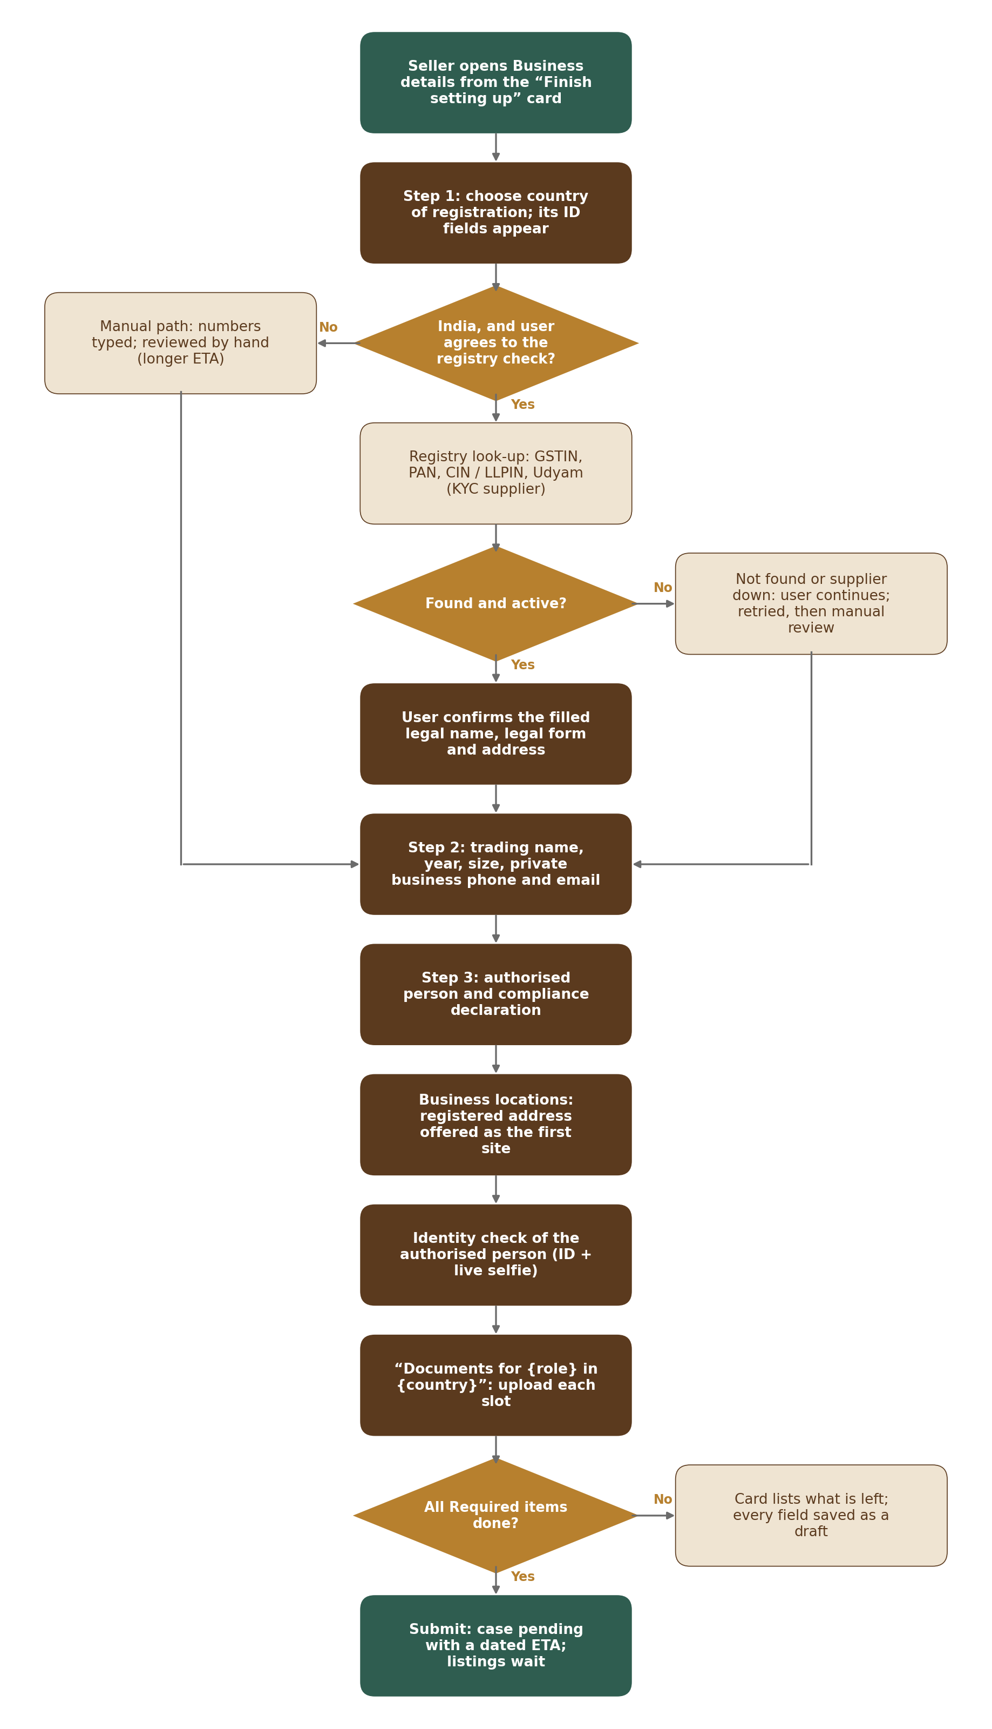
Figure 2 — Business setup: details → registry → locations → identity → documents → submit
Step | What happens
1 | Step 1: `PUT /v1/me/business/registration-country`. No country is pre-selected; the account country is listed first (BUS-001). The response carries the country’s ID fields from country_id_rules (label key, pattern, example, check-digit rule, group); a country without its own rules gets the fallback set ZZ and the longer ETA. Changing the country before approval deletes typed numbers after the client confirms (BUS-002); after approval it is refused (REG_COUNTRY_LOCKED).
2 | Each number is checked on the server with the same pattern and check digit as the browser; a mismatch returns 422 with the configured message for that field (BUS-003). India needs at least one of the main_registration group (GSTIN, CIN / LLPIN, Udyam or Udyam Assist) (ID_GROUP_REQUIRED).
3 | Registry look-up (India, R1): the client first records the registry consent (`POST /v1/me/verification-consents`, check_type registry_lookup). `POST /v1/me/business/registry-lookups` calls RegistryAdapter (limit 10 per day, DAT-011). Found → name, legal form, registration date, registered address and status are returned for the user to confirm (BUS-004); PAN is filled from the GSTIN where possible. Declined consent → manual path.
4 | Status rules (BUS-007): GSTIN active → accepted; suspended → accepted for manual review; cancelled → refused with REGISTRY_GST_CANCELLED; company or LLP other than Active → refused with the status. Not found → REGISTRY_NOT_FOUND notice and manual review (BUS-006). Supplier down → REGISTRY_UNAVAILABLE notice; registry_result pending_retry; the job profile.registry_retry retries every 30 minutes for 24 hours, then marks the case for manual review (BUS-005).
5 | The number is normalised, encrypted, hashed (HMAC) and masked. If number_hash exists on another profile, both rows are flagged for a business-claim review, the user sees REGISTRATION_ALREADY_USED with a dated ETA and the other account is told (BUS-016); nothing is blocked automatically.
6 | Step 2 saves trading name (M01 UrlService.checkStoreName), legal form (selects the checklist), year, size and the private business phone and email in profile_contacts (BUS-012, BUS-013). Step 3 saves the authorised person (BUS-014) and the compliance declaration with its version, time, IP and channel (BUS-015).
7 | Name matching (BUS-009) compares the confirmed legal name, the registry name and later the authorised person’s ID name (suffixes, initials, spelling, transliteration) and stores name_match_result; a mismatch is a reviewer warning, and the user may add a note and a document.
8 | Every step also works as drafts: each field is saved on blur or leave through DraftService, and a step is saved in full only on “Save and continue”; “Save and finish later” keeps the drafts and returns to the dashboard.
9 | IEC and issuing authority (BUS-020, BUS-021): an IEC is stored as a registration of type iec (encrypted, hashed, masked) and looked up through RegistryAdapter.lookupIec where available, otherwise marked for manual review; it is never part of the main_registration group. A registration from a country with several issuing bodies stores issuing_authority from the country_id_rules list (ISSUING_AUTHORITY_REQUIRED when missing). The name-mismatch note and its optional document are saved on the registration (BUS-022) and returned only on staff endpoints.

2.3 Identity check routes
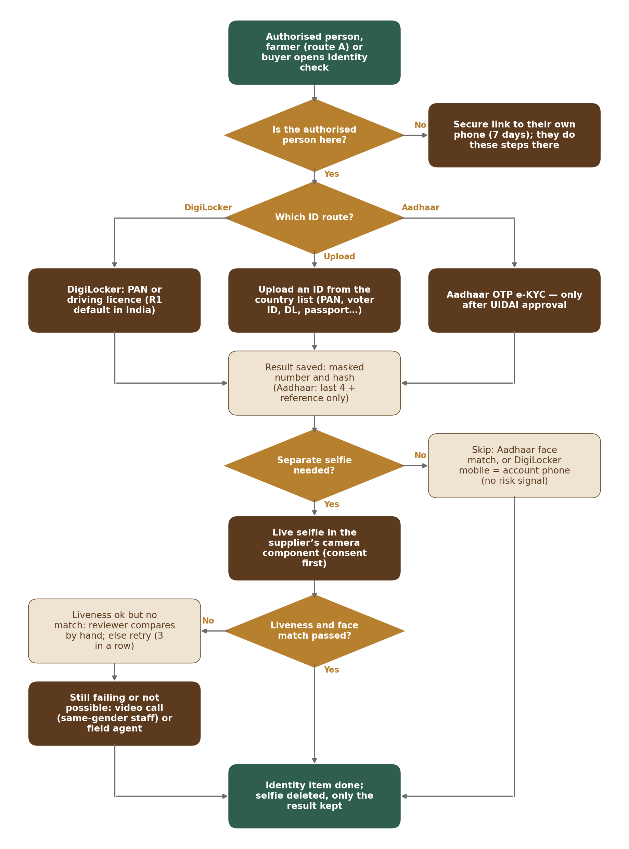
Figure 3 — Identity check: routes, selfie skip and alternatives
Step | What happens
1 | `POST /v1/me/identity-checks` with subject (account holder, authorised person, farmer, buyer) and method opens an identity_checks row in the profile’s draft case. The accepted ID types come from the per-country list; the Aadhaar route is offered only when the feature switch `r1.aadhaar_ekyc` is on (IDV-001, IDV-003).
2 | Authorised person not present: `POST /v1/me/identity-checks/remote-links` sends a secure link to the authorised person’s own phone (3 per day). The link token is random (256 bits), only its keyed hash is stored, it is valid 7 days and opening it needs a code sent by M02 Otp to that phone; the authorised person gives their own consent and runs the same steps at /verify/{token} (IDV-012).
3 | DigiLocker: redirect to DigiLocker with state and PKCE; the callback returns the signed PAN or driving licence; the service stores name, type, masked number and hash, issuing authority, reference and whether the linked mobile equals the account’s confirmed phone (digilocker_mobile_matches).
4 | Upload: the ID image goes through the M01 upload slot (Section 2.4 rules). Aadhaar is never in the upload ID-type list; an image that looks like an Aadhaar card is refused (AADHAAR_IMAGE_REFUSED, “Use the Aadhaar check or another ID.”) and the file is deleted at once (IDV-002). An expired ID is refused with its date (IDV-005). An ID that shows the person is under 18 starts M02’s under-18 process (ACC-007); 18 or over sets adult_confirmed_at (IDV-006).
5 | Aadhaar OTP (after UIDAI approval): the screen asks whether the mobile is linked to Aadhaar; EkycAdapter runs the OTP (the Aadhaar number is passed only to the licensed provider for the OTP check); only result, face-match flag, last 4 digits and reference are stored — never the number, XML or photo (a database check refuses a hash for Aadhaar rows).
6 | Selfie skip (IDV-008): no separate selfie when the Aadhaar check included a face match, or when digilocker_mobile_matches is true and no risk signal is present (M02 risk flag, duplicate document, name mismatch, country difference). Uploaded IDs always need the selfie.
7 | Live selfie: the selfie consent is recorded (selfie_match); `POST …/{id}/selfie-session` returns the supplier SDK token; capture happens only in the supplier’s live-camera component (no upload). The supplier sends a signed callback to `/internal/profile/selfie-results`; the service stores liveness, face match, score and reference, then calls SelfieAdapter.delete and deletes any M01 temporary file; selfie_deleted_at is set (IDV-007, IDV-009).
8 | Failures: 3 failed attempts in a row (5 a day) → alternatives offered: video call with a same-gender staff member or field agent in person (IDV-010, IDV-013); farmers get “Ask a field agent” after 2. Liveness passed but no face match → manual_review, the reviewer compares by hand and may ask for a second ID (IDV-011). No camera or permission denied → “Continue on your phone” hand-off (`POST /v1/me/handoffs`, a signed-in link valid 10 minutes, shown as a QR code) (IDV-014).

2.4 Document submission
Step | What happens
1 | `GET /v1/me/verification` returns the checklist for the role and the registration country (businesses) or account country (individuals): the document types for the Document type dropdown (ending with “Other document”), the required types for the “You need” list, accepted formats, size limit, validity rules, sample and the “Documents for {role} in {country}” title (DOC-001, DOC-029). A country with no checklist gets the basic set with is_fallback_checklist (DOC-002) and an Admin alert (M15).
2 | Upload: `POST /v1/me/verification/upload-slots` calls M01 FileService.createUploadSlot(owner, purpose verification_document, type, size) — a pre-signed POST with the size limit (M01-FR-SEC-011); files over 2 MB use multipart parts (DOC-014). Limit 20 uploads per day (DAT-011). The client then calls `POST /v1/me/verification/documents` with the chosen document type (its checklist slot), number, issuing country and dates (“Add”, DOC-026); the service checks format, locked PDF (encrypted PDF dictionary, DOC-009), page count (up to 10, DOC-010), expiry date (DOC-012), and records M01 conversion of HEIC, HEIF and WEBP (DOC-008). The document-type check and forgery check run on the India-hosted DocumentCheckAdapter and give warnings only (DOC-013, DOC-019).
3 | The document number (when the type has one) is encrypted, hashed and masked; a hash already used by another profile sets duplicate_on_other_profile (flag for the reviewer) and the hash is shared with M02 for ban-evasion signals through Verification.documentNumberHashes (DOC-019).
4 | Before submission the user may delete a file (`DELETE …/documents/{id}`). `POST /v1/me/verification/submit` (5 per day) checks that every required document type is added, the required setup items are done and consents are recorded; the case moves to pending, submitted fields are locked (DOC-015) and due_at = LocaleService.addBusinessHours(now, 48) (VER-007). The response carries the dated ETA; the page shows it in the user’s time zone (VER-008).
5 | “Withdraw” (`POST …/withdraw`) moves the case back to draft; only changed items are reviewed again (DOC-015).

2.5 Review, decision and the publishing gate
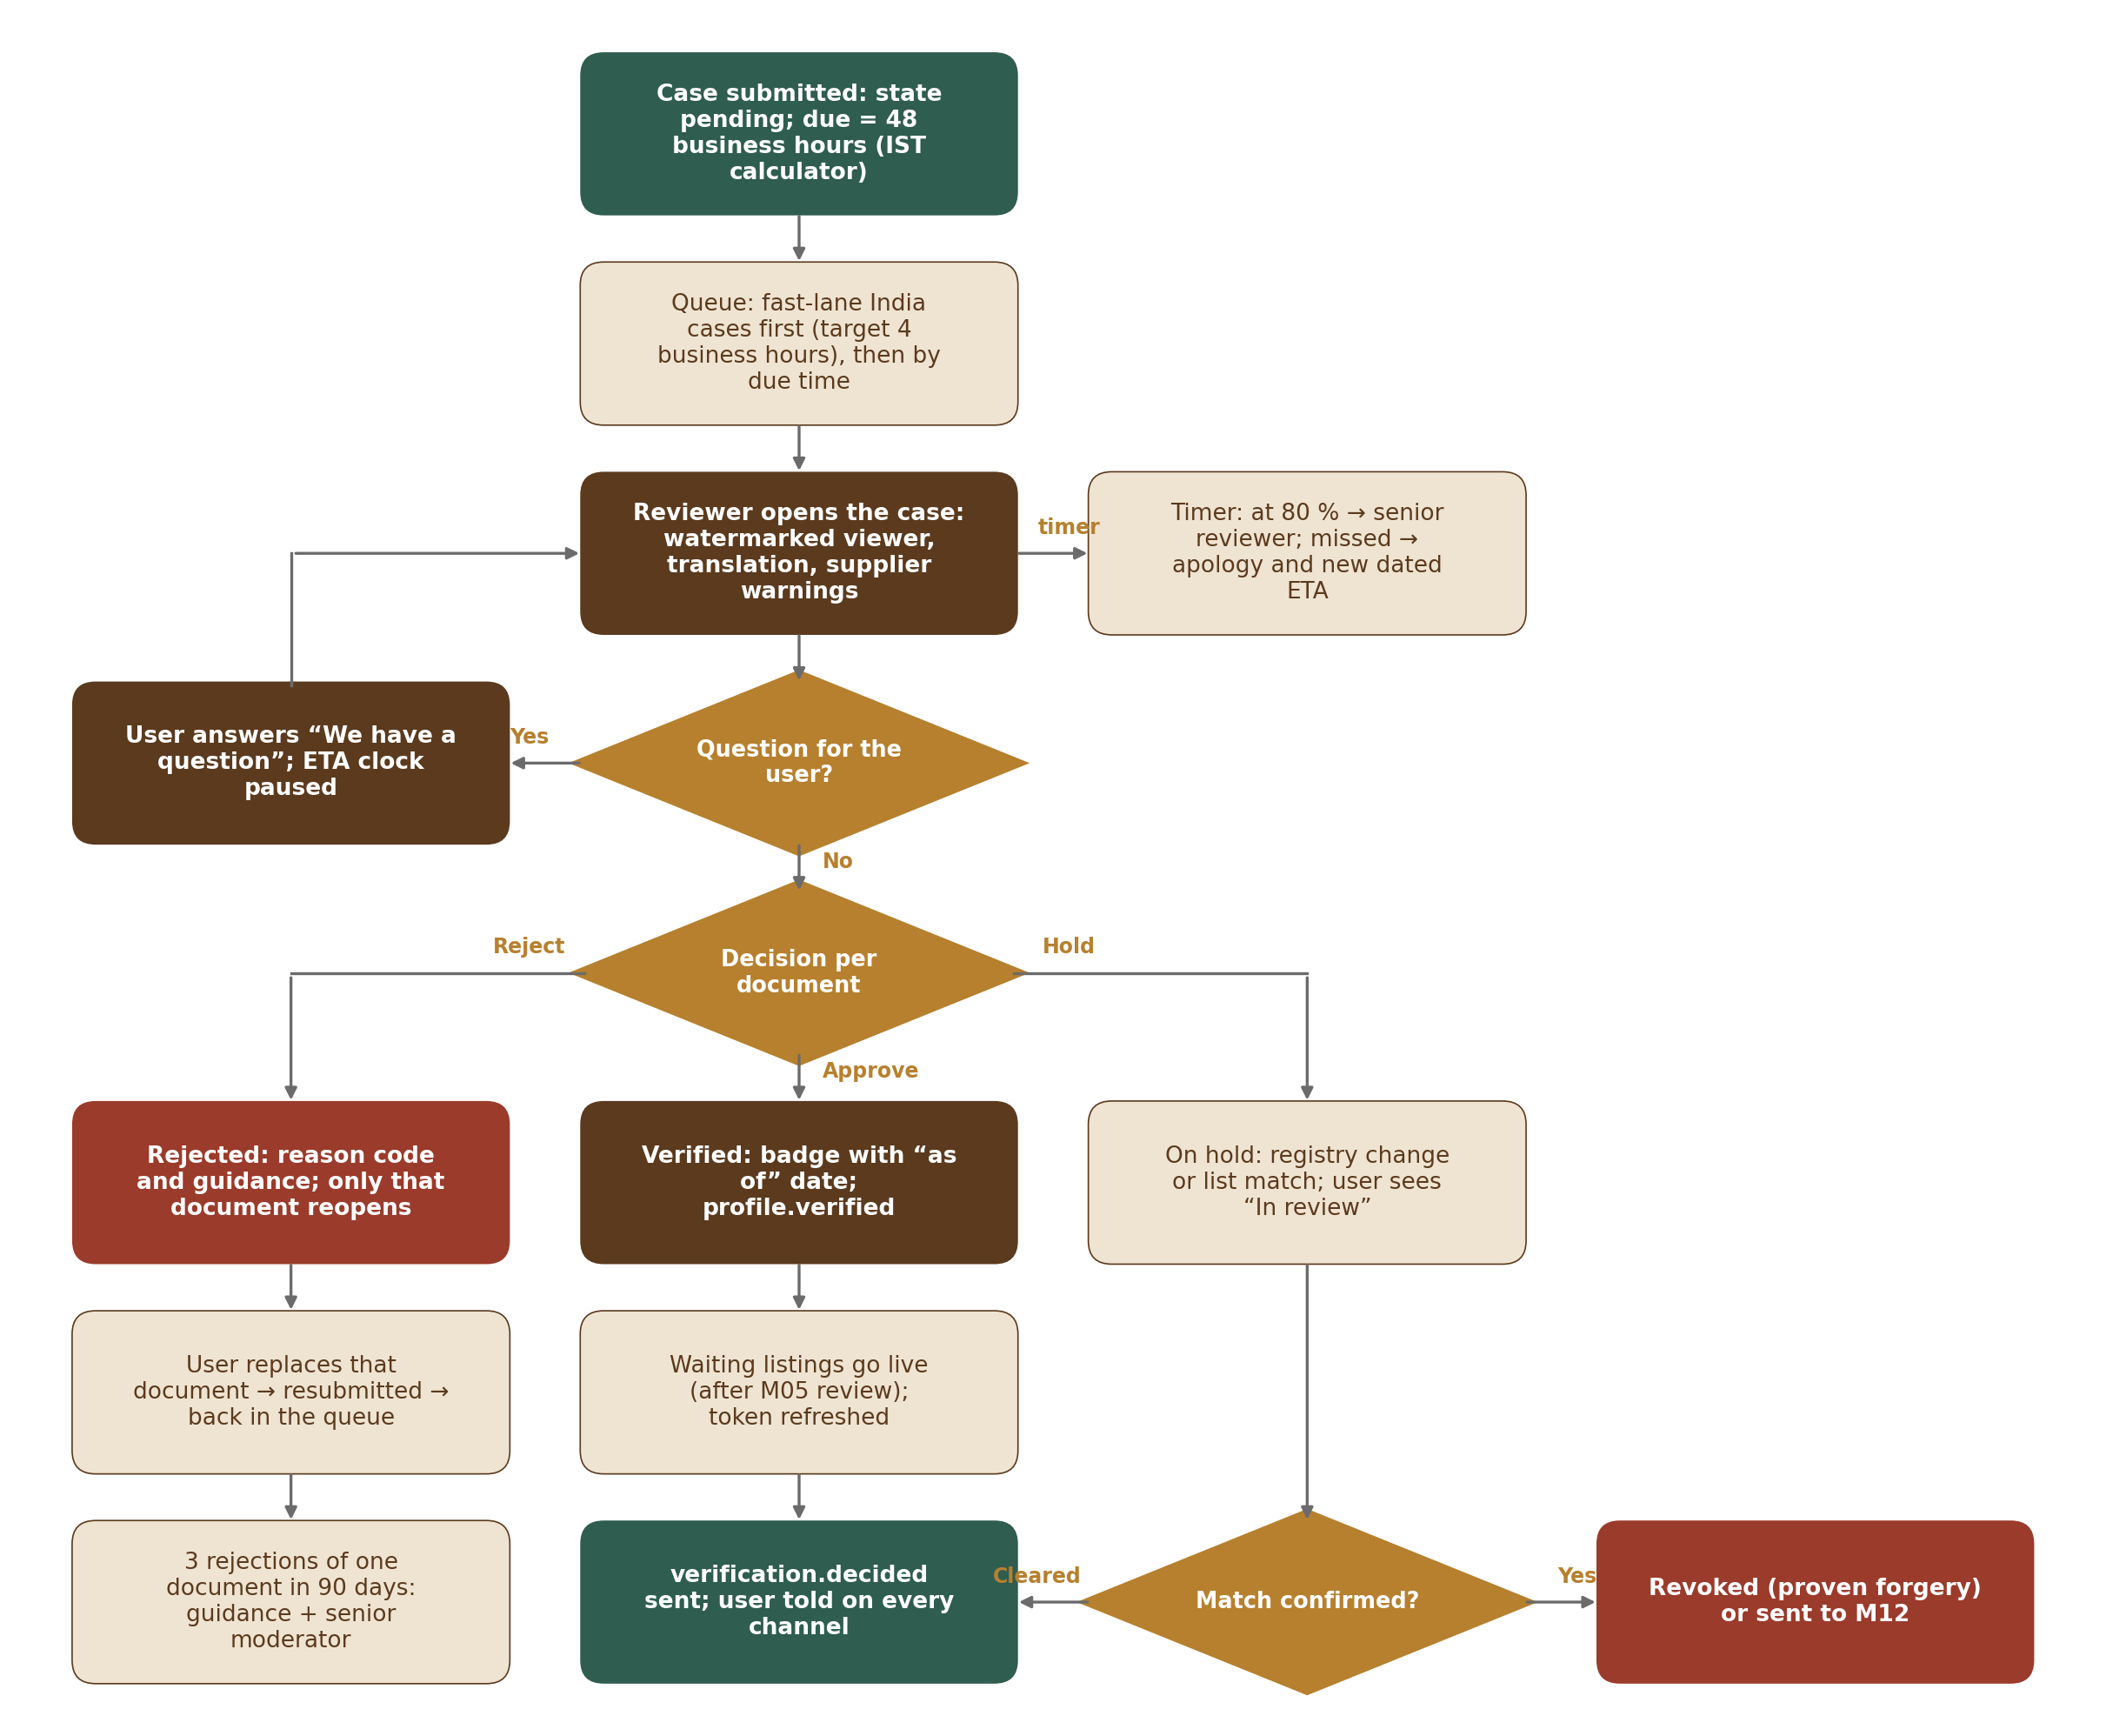
Figure 4 — Verification review: queue, fast lane, decision, rejection loop and escalation
Step | What happens
1 | Queue (staff screen A, built in M15 on `/v1/admin/verification/cases`): fast-lane cases first — India, registry active, names match, identity passed or skipped, no flags; target 4 business hours (DOC-023) — then by due_at. Cases are routed by the languages the documents need (reviewer_languages). Automatic approval (DOC-023): only while the feature switch profile.review.auto_approve is on (off by default), a case that is fully matched India fast lane at submission is approved by VerificationService without a reviewer (decided_by system, auto_approved = true) through the same transaction as a reviewer approval; each one is put on the audit list with a probability of profile.review.auto_approve_audit_percent (10) (audit_sampled = true). A Moderator records the audit outcome (`POST …/{id}/audit`: passed or problem_found with a note); problem_found leaves the approval in place and the Moderator uses the normal follow-ups (question, re-verification, revoke by a Senior Moderator).
2 | The reviewer opens a document through a viewer session (`GET …/documents/{id}/view`): the server renders pages as images with a watermark (reviewer name, time, case number); no download unless the staff role allows it; every view goes to the M01 audit log (DOC-021).
3 | Translation (DOC-020): `POST …/documents/{id}/translate` extracts the text on an India-hosted OCR step, removes ID and document numbers (patterns from country_id_rules plus generic long-digit rules), then calls M01 AIGateway.call(module M03, purpose reviewer_translation, dataLevel Restricted-redacted). The result is labelled “machine translation” and stored as a private file; a certified translation is asked for only when the text stays unclear.
4 | Question: `POST …/question` sets question_text and paused_at; the ETA clock stops until the user replies (VER-006).
5 | Decision per document (`POST …/documents/{id}/decision`): accept or reject with a reason code from the list in M03-6 Section 16.2 and a plain message (DOC-022). Only rejected documents reopen. The 2nd rejection of the same slot offers a call-back; the 3rd in 90 days sets senior_review_required and the next submission can be decided only by a Senior Moderator (a Moderator with the Senior Moderator flag on the staff token) (VER-010). The account is never blocked.
6 | Case decision (`POST …/decision`): verified, rejected, on_hold or revoked. In one transaction VerificationService updates the case, profiles.verification_state, verified_at and verification_expires_at, BadgeService adds or removes badges, ProfileService locks the legal name and the billing country (TRS-009) and recomputes is_public; the outbox receives verification.decided (always) and profile.verified (first approval) and badge.changed (each badge). If the registration country is not in the Country table or billing map, approval is refused and the case put on hold with an Admin alert (DOC-024).
7 | After commit: M02 is asked to refresh the user’s token (VER-018); the decision goes to the user on every confirmed channel through M13 and cannot be switched off (VER-011, NTF-003); a first verified seller is invited to switch on two-step sign-in.
8 | Publishing gate hand-off to M05: M05 calls `Verification.canPublish(profileId)` before publishing, quoting, buying leads, advertising or export listings; it returns allowed only when the M02 account is active and the verification state is verified (either state can only remove access — VER-003). For a listing of wood, chips or oil M05 also calls `SupplyDeclaration.required(profileId, category)`; it returns required when the seller has not yet made the declaration (TRS-006), and M05 holds the listing with the message to finish it. Listings submitted while pending wait in M05’s “Waiting for your verification” status; on profile.verified M05 publishes those that passed its own review, and they stay waiting through a rejection (VER-004).
9 | Escalation (job profile.sla_watch): at 80 % of the target the case is escalated to the Senior Moderators (escalated_at set; only a Senior Moderator can take it); if due_at passes, the user gets an apology and a new dated ETA and the M15 dashboard shows the case at risk (VER-009).

2.6 Verification states
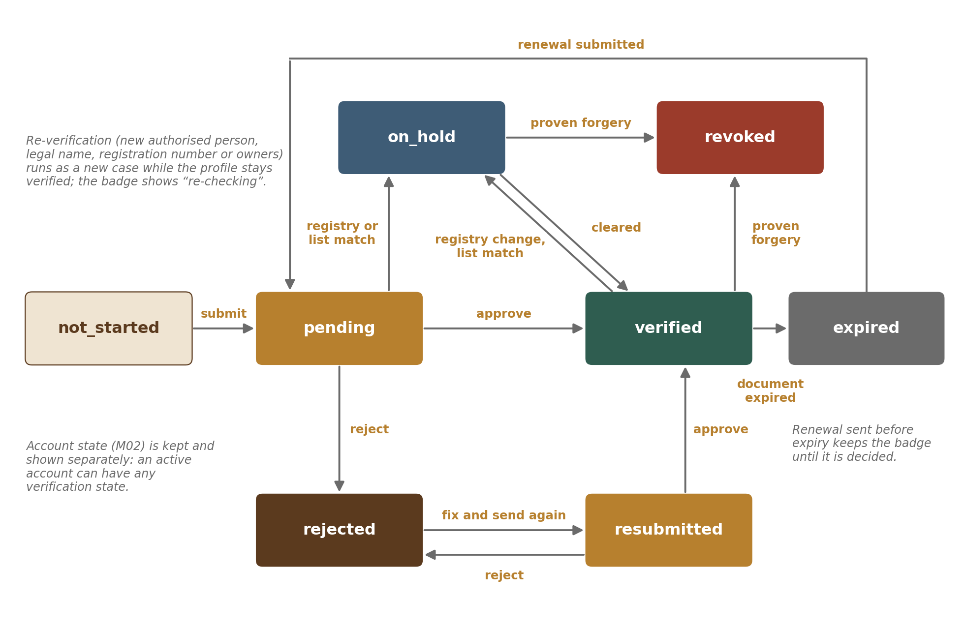
Figure 5 — Verification states
The states, what the user sees and what is allowed are defined in M03-2 Section 8.1. VerificationService is the only code that changes profiles.verification_state; every change is written with who, when and reason and sends verification.decided in the same transaction. A pending case never fails or expires by itself (VER-005). Account state (M02) and verification state are kept and shown separately (VER-002).

2.7 Expiry, grace and renewal
Step | What happens
1 | expires_at is set at approval from the documents that really expire (trade licence, nursery licence, ID) or the default validity per type; registrations without an expiry (GSTIN, Udyam, CIN) rely on the monthly registry re-check instead (DOC-004, BUS-018).
2 | The job profile.expiry_reminders plans reminders 60, 30 and 7 days before and a final notice on the day (VER-012); farmers get SMS or voice and a field-agent task.
3 | A renewal submitted before expiry (`POST /v1/me/verification/renewals`) keeps the badge and publishing until it is decided (VER-014).
4 | At expiry (job profile.expiry_apply, hourly): state expired, badge removed, new publishing paused, listings_grace_until = now + 30 days; verification.decided (expired) carries the grace end so M05 keeps live listings until then (VER-013).
5 | At grace end (job profile.grace_hider, daily): M05 `Listings.hideForVerification(profileId)` hides the live listings (never deletes); a reminder went 7 days before. On an approved renewal verification.decided (verified) lets M05 restore them.
6 | An account that is deactivated has its expiry clocks paused (DAT-010).

2.8 Re-verification
Step | What happens
1 | Triggers (VER-016): a new authorised person, a legal name change, a new registration number, a new registration country, or a change in owners with 25 % or more (in “My profile” the client shows the re-check warning before the edit form opens, PRF-020; the server does not depend on it); the monthly registry re-check finding cancelled, suspended or struck off puts the case on hold instead (VER-015).
2 | VerificationService opens a case of type reverification holding only the changed part (for example the new authorised person’s identity check), sets rechecking_since, sets the business badge to rechecking and writes profile.reverification_started (M05, M07). Listings stay live up to 30 days during the review.
3 | Approval clears rechecking_since and re-dates the badge (badge.changed); rejection or no answer within 30 days moves the state as for a normal rejection and M05 pauses new publishing.
4 | An attempt to hand the account to another person or business is refused (ACCOUNT_TRANSFER_NOT_ALLOWED); the new owner signs up themselves (VER-017).

2.9 Role change
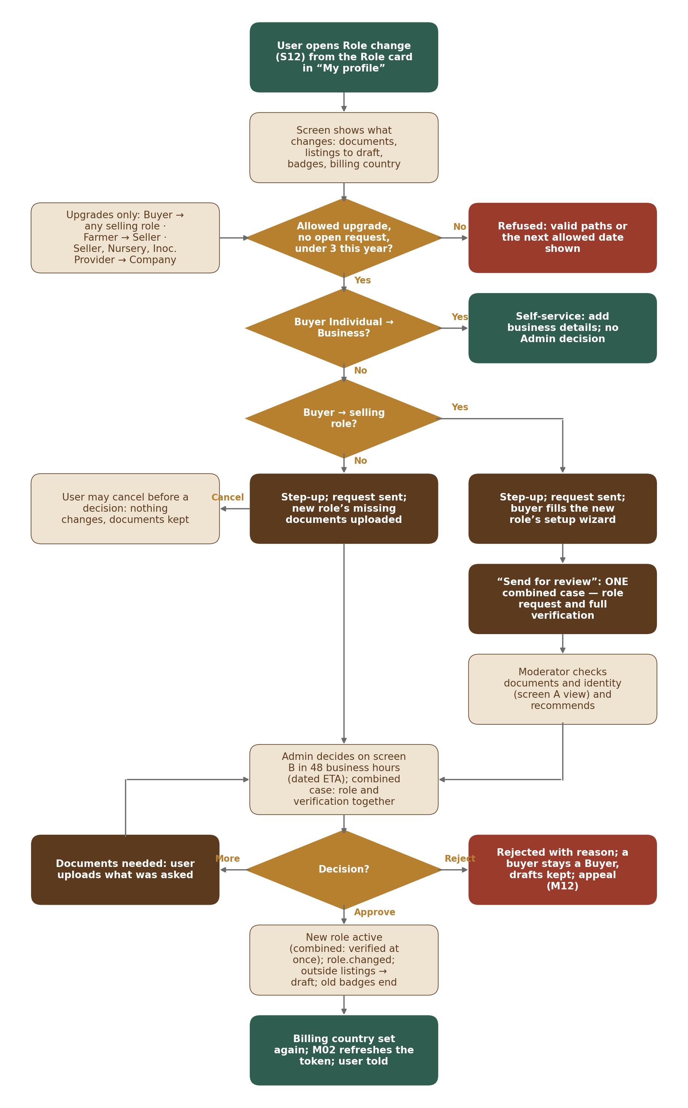
Figure 6 — Role change request
Step | What happens
1 | `GET /v1/me/role-change/preview?to=` returns what changes: new role’s documents, listings outside the new role (count from M05 Listings.countOutsideRole), badges that end and the billing country that will apply (ROL-009).
2 | `POST /v1/me/role-change` (step-up, M02 StepUp.require naming the action) checks the allowed upgrade paths from the setting profile.role_change.paths (ROL-010; 422 ROLE_PATH_NOT_ALLOWED with the valid paths), one open request (409 ROLE_CHANGE_OPEN) and 3 per year (429) (ROL-011). It creates role_change_requests and a verification case of type role_change for the new role’s documents; due_at = 48 business hours.
3 | Buyer Individual → Business (`POST /v1/me/buyer-upgrade`) is self-service: profile kind business, new role assignment source buyer_upgrade, interests and history kept; Business verified follows the normal business verification (ROL-015).
4 | Before a role is used for a submission, `POST /v1/me/role-correction` switches to another role — for a user who joined through an invitation, one the invitation allowed (drafts kept, logged); a role the invitation does not allow answers M02’s INVITE_ROLE_NOT_ALLOWED (422, M02-6 Section 19.1); after the first submission it answers ROLE_CORRECTION_CLOSED (ROL-006).
5 | Admin decides on staff screen B (`POST /v1/admin/role-changes/{id}/decision`). Approve: in one transaction the old role_assignment ends, the new one starts, old-role badges end (badge.changed), the billing country is set again from the new verification, role.changed is written (M05, M11, M13, M02) (ROL-014). M05 moves listings outside the new role to draft and reports the count. M02 refreshes the token.
6 | Cancel (`POST /v1/me/role-change/cancel`, no step-up) sets cancelled; nothing else changes and documents stay on file (ROL-013); a cancel after the decision answers 409 ROLE_CHANGE_CANCEL_TOO_LATE.
7 | Buyer → selling role (ROL-017): the request is created with is_combined = true and its case has case_type role_change_combined, holding the full verification of the new role. While it is open, SetupCardService and the wizard use the requested role (the Buyer role stays active). “Send for review” submits the one case. A Moderator reviews documents and identity on the staff screen A view (per-document decisions as Section 2.5) and records a recommendation (`POST /v1/admin/role-changes/{id}/recommendation`: approve or reject, with a note). The Admin decides on staff screen B: approve runs, in one transaction, the role switch above and the verification approval of Section 2.5 (verified state, badges, legal name and billing country lock); the outbox receives role.changed, verification.decided and, on first approval, profile.verified. Reject leaves the Buyer role, sets the case to rejected with the per-document reasons and keeps drafts and documents.

2.10 Farmer routes A and B, including offline agent forms
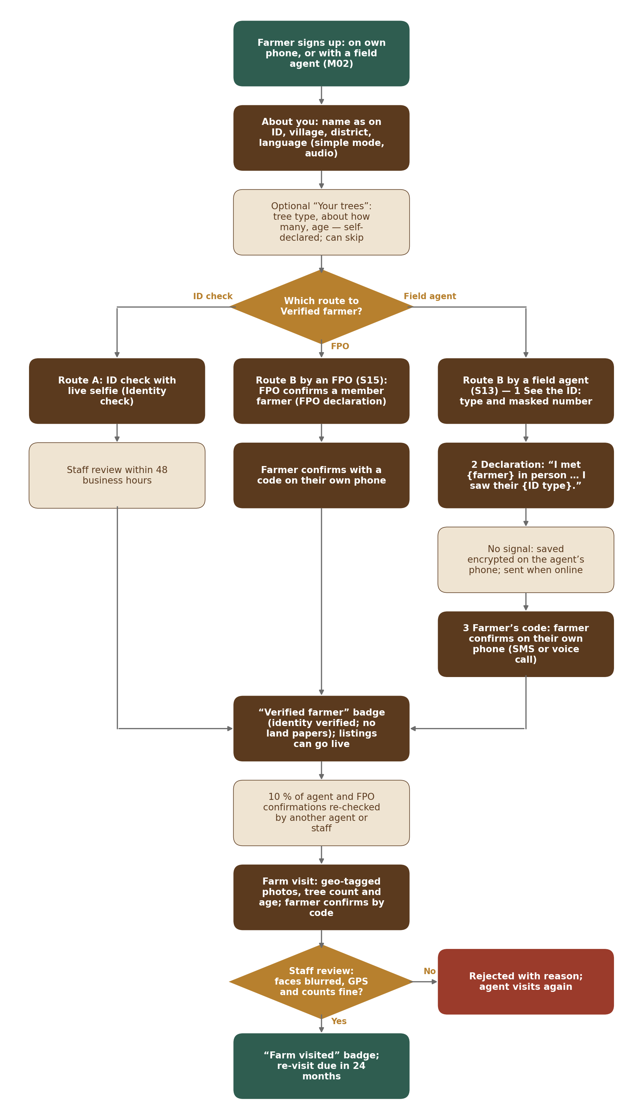
Figure 7 — Farmer verification: routes A and B, offline agent forms and farm visit
Step | What happens
1 | The farmer (or a field agent under an active delegation, checked with M02 Delegation.check for every agent call; scope farm_profile_edit) fills “About you” and, if they want, the self-declared “Your trees” (`PUT /v1/me/farm`, `/v1/agent/farmers/{id}/farm`) (FRM-001, FRM-002, FRM-021). No land document is asked, and the farm record holds only tree type, tree count range and age: plantation name, place and area, inoculation status, forest-department number and map pin are asked on the listing (M05 / M06).
2 | Route A: identity check with selfie (Section 2.3); staff review as Section 2.5; approval gives Verified farmer (identity verified, FRM-005).
3 | Route B by a field agent (S13, three steps): the agent records the ID type seen and masked number (identity_checks, method field_agent_in_person, seen_at and encrypted place) and signs the versioned agent declaration “I met {farmer} in person on {date} at {place}. I saw their {ID type}.” (compliance_declarations, agent_confirmation). M02 Otp sends a code to the farmer’s own phone (SMS or voice call); the farmer types it; the case goes to review (FRM-006). A farmer with no ID can only use route B with a village-council certificate (FRM-007).
4 | Offline: the installable agent web app saves the forms encrypted on the device (M03-4 Section 10) and sends them later with `POST /v1/agent/sync`: a batch of items, each with its client idempotency key. The server processes each item on its own: new key → created; known key → the stored result is returned; conflict (the farmer’s record changed on the server after the device copy was taken) → 409 item result with both versions for the agent to choose (FRM-012). The farmer code step always happens online with the farmer present.
5 | FarmService registers each route-B confirmation for the quality sample (Section 2.13).

2.11 Farm visit
Step | What happens
1 | The agent creates a visit (`POST /v1/agent/visits`, offline allowed): geo-tagged photos through the M01 upload slot (photo location kept private and encrypted), GPS accuracy, tree count and age observed, inoculation seen, notes. If accuracy is worse than 100 m or GPS is off, a manual pin and reason are required (FRM-010).
2 | The farmer confirms the visit with a code on their own phone (`POST /v1/agent/visits/{id}/farmer-confirm`) (FRM-009).
3 | M01 makes public copies with faces blurred (face-blur step of the photo pipeline, M01-FR-FIL-028); the reviewer on staff screen C checks that no face or home shows (face_blur_checked), GPS and counts, and approves or rejects (`POST /v1/admin/farm-visits/{id}/decision`).
4 | Approval: BadgeService gives or re-dates Farm visited (as_of = visit month) and sends badge.changed; next_visit_due_on = visit + 24 months; a re-visit task is queued per district 30 days before (FRM-011). After 24 months the badge shows “last visited {month year}”; after 36 months without a visit it is removed. Where no field agent covers the district, the badge is kept as “Farm visited {date}”, a staff visit (video or in person) is queued and offered, and the badge is removed only if the farmer does not take the offered visit within 60 days, or 36 months pass with no agent and no staff visit taken (FRM-011).

2.12 FPO confirmation
Step | What happens
1 | Only a verified Company with the active Co-operative / FPO badge can use FPO endpoints (TRS-004, FRM-016). It uploads a member list (CSV or spreadsheet: name, village, phone, member number) as an M01 file; FpoService validates rows (FPO_LIST_INVALID with the row number), creates fpo_memberships (listed) and matches existing farmer profiles by phone.
2 | For each member the FPO confirms membership with the versioned FPO declaration (fpo_confirmed_at, fpo_declaration_id); the farmer then confirms by code on their own phone (farmer_code_confirmed_at); only then does the membership count as route B for that farmer (FRM-016, FRM-017).
3 | A farmer naming an FPO that is not on OudhTrade creates a listed row with source farmer_named_fpo and an invitation request to Admin; meanwhile the farmer uses the ID check (route A) or the agent route (FRM-018).
4 | Membership end or FPO dissolution sets ended_at and badge_grace_until = +90 days for farmers verified only through that FPO; the job profile.fpo_grace removes the badge after that unless another route passed (FRM-019).

2.13 Agent and FPO quality re-checks
Step | What happens
1 | The daily job profile.agent_quality_sampling selects a random 10 % (setting) of the previous day’s route-B confirmations by agents and FPOs, and every farm visit for its own review, into agent_quality_checks with a due date; the checker is another agent from a different partner or a staff member (FRM-013).
2 | The checker records the outcome. confirmed → agent quality record updated. fake_confirmation → the agent (field_agents.status suspended) or the FPO (badge suspended, FPO endpoints refused) is suspended, an M12 case is opened, and every farmer they confirmed gets a triggered re-check; affected farmers keep their badge until their own re-check decides.

2.14 Enhanced check
Step | What happens
1 | When a user tries to create an Opportunity, a land, plantation or business sale, or declares yearly exports over the big-exporter threshold (profile.enhanced.big_exporter_threshold, USD 100,000 or the INR equivalent — starting value), M05 asks `Verification.hasEnhancedCheck(profileId)`; the check is not a wizard step and opens only after Business verified; the dashboard item shows the entry disabled with the reason until then (ENH-001). It is only for the business selling roles (Seller, Company, Nursery, Inoculation Provider): for a Farmer hasEnhancedCheck is never asked and the API refuses the check; a farmer’s Opportunity listing of own trees or land relies on Verified farmer plus land papers on the listing (M05 / M06).
2 | `PUT /v1/me/enhanced-check` collects address proof, owners (share 25–100 %, shares ≤ 100 % in total) or the “No one owns 25 % or more” declaration with the senior manager’s name (ENH-002). Land-rights proof is not collected here: M05 / M06 ask for it on each land or plantation listing.
3 | The bank check is optional (bank_check_requested). `POST /v1/me/enhanced-check/bank-check` (bank consent first) takes the bank country and its identifier type (ifsc, iban, swift or routing). India: BankCheckAdapter runs the test deposit with account number, IFSC and the expected name; only the result and the bank name are stored; name mismatch, joint or NRE account or supplier down → upload of a cancelled cheque or statement for manual review. Other countries: the user uploads a recent bank statement or bank letter (bank_proof_document_id; the user may cover transaction lines) and a reviewer records the result; account numbers are never stored as data. Every bank proof file is deleted after review by the job profile.document_deletion, profile.documents.delete_after_days (90) days after the decision whatever the result; only the result and bank name are kept (ENH-003, DAT-007).
4 | Submission creates a case of type enhanced; approval gives “Enhanced check passed” (badge.changed); its help text includes “bank account confirmed” only when bank_check_result is passed (ENH-004). A later change of owners or authorised person sets recheck_needed; a bank change does so only when a bank was given.
5 | Sanctions R1 (job profile.sanctions_weekly_batch, Monday 06:00 IST): builds the list of names (business, authorised person, owners) of non-India sellers and export-enabled sellers with nationality; a Senior Moderator checks them against the free UN, US (OFAC) and EU list files and enters the results (`POST /v1/admin/sanctions-batches/{id}/results`, M03-6 Section 16.13). A possible match puts the verification on hold (the user sees only “In review”); only a Senior Moderator clears or confirms it (`POST /v1/admin/sanctions-matches/{id}/decision`), recorded with reviewer, lists and date; confirmed matches go to M12 (ENH-005, ENH-008). From R2 SanctionsAdapter screens at verification and on list updates, including PEP (ENH-006).

2.15 Store name change
Step | What happens
1 | `POST /v1/me/store-name` with the new name: M01 UrlService.checkStoreName checks rules, uniqueness and reserved names; the service refuses a change within 90 days of the last (STORE_NAME_TOO_SOON with the next date) (PRF-011).
2 | In one transaction: profiles.trading_name, store_slug and trading_name_changed_at are updated, a name_history row is written with formerly_shown_until = +90 days, and profile.renamed is written (M01 keeps the old address as a permanent redirect; M07 re-indexes).
3 | The storefront shows “Formerly {old name}” until formerly_shown_until. The legal name cannot be changed here; `POST /v1/me/reverification` with reason legal_name starts re-verification instead (PRF-012).

2.16 Setup card computation
Step | What happens
1 | SetupCardService.compute(profileId) reads the item table of M03-2 Section 3.2 as configuration (item key, roles, group, condition, screen, time needed, what to have ready) and evaluates each item for the profile’s live role and kind (or the requested role while a combined buyer → selling role request is open, ROL-017) from current data: profile info, business details and locations saved, identity check passed or submitted, required document types added and the case submitted, route B confirmation, farmer “About you” and “Your trees”, interests, extras, password set (M02 Identity.getAccount), first listing or requirement (set by listing.published and requirement.posted) (DSH-010).
2 | Verification items count as done when submitted, with a separate chip “Waiting for review — expected by {date}” (DSH-011). Drafts never count. Two-step sign-in and links never count (DSH-013). The plan item is hidden in R1 (DSH-014).
3 | When all Required items are done the first time, setup_completed_at is stored, the card collapses for good and setup reminders stop (DSH-012, NTF-001). Later problems appear as banners and in “Needs your attention”. After that the open Recommended items form the “Make your profile stronger” card (DSH-018), which hides when every Recommended item is done. Buyers have no Required items: setup_completed_at is set when the buyer profile is created, and they see only the “Make your profile stronger” card; “Not now” adds the item key to profiles.setup_dismissed_items and moves it to the end of the card.
4 | “Continue setup” (DSH-017): compute also returns next_step — the first wizard step, in the role’s step order, that holds an open Required item (then open Optional steps); each item carries the wizard step it opens (setting profile.setup_card.items).
5 | The result is cached per profile for 60 seconds and cleared on any M03 write for that profile, so the card is always current after the user’s own change.

2.17 Link ownership check
Step | What happens
1 | `POST /v1/me/links` saves the link (type website, instagram, facebook, youtube, linkedin or x; blocked hosts refused) with scan_status pending; LinkScanAdapter.scan runs at once (PRF-009, PRF-010).
2 | `POST /v1/me/links/{id}/ownership` with the method (meta_tag or file for websites; bio_code for social profiles) returns a one-time code; only its keyed hash and an end time of 7 days are stored (PRF-016).
3 | “Check now” (`POST …/ownership/check`) and the job profile.link_ownership_check call LinkScanAdapter.findCode; when the code is found, ownership_confirmed_at is set. A link is public only when it is safe, confirmed, switched on and the profile is verified; the owner sees “Checking” until then and “Link confirmed” after. An ended code answers LINK_CODE_EXPIRED; the user asks for a new one.

2.18 GST registered badge, capability and location details
Step | What happens
1 | GST registered (TRS-012): when a business case is approved with a GSTIN whose registry_status is active, BadgeService gives gst_registered (as_of = registry check time, source_ref = the registration). The monthly re-check (job profile.registry_recheck) removes it when the GSTIN is cancelled; each change sends badge.changed. Trusted (TRS-013, R2): M10 calls Badge.grant / Badge.remove with its reference; M03 stores it and sends badge.changed.
2 | Capability (TRS-014, TRS-015): `PUT /v1/me/capability` checks the role (Nursery or Inoculation Provider), the fixed lists and the numbers, stores service_capabilities and sets the bands from the configured band table; getTrustFacts and Capability.get return only lists and bands, never service_radius_km or the exact figures.
3 | Location details (LOC-007 to LOC-009): site photos and video use M01 upload slots with purposes location_photo and location_video; they are public only after M01 marks them approved (moderation.file_decided); file.held keeps them hidden with SITE_MEDIA_NOT_SHOWN to the owner. Contact hours are stored per location and rendered as “Usually available …” in the viewer’s language.

2.19 Other documents and checklist growth
Step | What happens
1 | Every dropdown returned by `GET /v1/me/verification` ends with “Other document” (slot other); adding one needs other_title (OTHER_DOC_TITLE_REQUIRED). The reviewer decides it like any document, but it never counts as a required type and SetupCardService and BadgeService ignore it (DOC-027).
2 | The weekly job profile.other_document_report groups other titles by issuing country and role (normalised text, similar titles grouped) and writes the counts for the Admin report (`GET /v1/admin/other-documents/report`). “Add to checklist” creates a draft change of document_checklists for that country and role with a retention class and opens it in the document checklists editor (M03-6 Section 16.7); it is published with a second approver like any checklist change (DOC-006, DOC-028, DAT-012). Later users then see the new type in the dropdown.

2.20 Away mode (R3)
Planned release: R3. The endpoints, the job profile.away_end and the away settings below are fully specified; the team decides the timing during development. Until away mode is built, a seller who needs a long break can deactivate the account (M02, PRD-IDN-006).
Step | What happens
1 | `PUT /v1/me/away` with away_until and an optional away_message (PRF-018): the role must be a selling role; away_until must be after today and at most profile.away.max_days (60) ahead (AWAY_TOO_LONG); the message is at most 300 characters and contact details are refused (CONTACT_IN_TEXT). A field agent uses `PUT /v1/agent/farmers/{id}/away` after Delegation.check (scope farm_profile_edit). `DELETE /v1/me/away` ends it early.
2 | No event is sent. Profile.awayStatus(profileId) returns away_until and the message while today ≤ away_until; M09 uses it for the automatic reply and to leave the reply measure out, M07 and M05 for the “Away until {date}” label. The job profile.away_end clears ended rows each night; reads never depend on it. Listing expiry and verification clocks are not touched.

2.21 Staff-awarded badges
Step | What happens
1 | Badge types live in badge_types (M03-5 Section 4.7). The 12 automatic types are seeded; only their help text, translations and time settings can change without code. A staff-awarded type (TRS-016) is created as a draft in the badge types editor (M03-6 Section 16.12) and becomes active only when a Super Admin who is not the creator approves (high impact, DAT-012; approved_by must differ from the creator). The service and a check constraint refuse names containing “Verified”, “Certified” or “Tested” (the service also checks translations) (BADGE_NAME_NOT_ALLOWED).
2 | A user whose role is in allowed_roles applies with `POST /v1/me/badges/{badgeKey}/applications`, which opens a case of type staff_badge with the evidence as documents; the reviewer decides it on staff screen A. Approval writes a badges row (as_of_at = decision date, expires_at from validity_months) and badge.changed; expiry and removal follow the normal badge rules.

3. Internal Interfaces
Other modules call these interfaces inside the Core API; they never query the profile schema.
Interface | Main operations
Roles | current(profileId) → role, profile kind, since · profileFor(accountId) → profile ID · allowedCategories(role) → categories the role may list (M04 role-to-category table, PRD-TAX-005; the top-level categories from the Module 4 taxonomy, six today) · canUseRole(role, profileKind, invitationRoles) (used by M02 sign-up) · allowedPaths(role) → roles the user may request (ROL-010, S01 and S12 texts)
Verification | canPublish(profileId) → allowed / refused with reason (account active AND verified; used by M05, M08, M09, M11) · state(profileId) → verification state, verified_at, expires_at, rechecking · isVerifiedSeller(accountId) (used by M02 recovery and number reclaim) · hasEnhancedCheck(profileId) · documentNumberHashes(accountId) (M02 ban-evasion signals) · verifiedOnly(profileId) (M07 “verified only” signal)
Profile | getTrustFacts(profileId) → trading name with the legal business name, display name, “Formerly” name, registration country, public place, business size band, public sites (type, label, “Usually available” hours, approved photos and video), short bio and description, capability lists and bands, badges with “as of” dates, each verified public registration (GSTIN, CIN / LLPIN, Udyam, IEC — never PAN; country_id_rules.shown_publicly) with masked number and status, member since, away status (“Away until {date}”; from R3), languages, confirmed links, compliance-declaration flag; farmers: display name, district, tree type, tree count range and age (flagged self-declared), and “Usually available” days and hours when set; never contacts, exact addresses or map pins (PRF-001, PRF-002) (M07 adds M10 trust level and the M09 reply measure “Replies within 24 hours: {n} %”) · getBuyerCard(profileId) → name, country, buyer type, badges, member since (M09) · billingCountry(profileId) → country, currency, locked_at (M11) · primaryRegion(profileId) → region pre-fill (M05, M08) · isPublic(profileId) · byShareLink(storeName) → profile ID when that storefront is public, following old store names (M02 sign-up from a share link, PRF-017) · awayStatus(profileId) → away_until and away message while away (R3; PRF-018; M09 automatic reply and reply measure, M07 and M05 “Away until {date}” label)
Badge | list(profileId) → active badges with type, kind (automatic or staff_awarded), name, help text, status, as_of · types() → active badge_types with where each is shown (M07 filters) · has(profileId, type) · grant(profileId, trusted, asOf, ref) / remove(profileId, trusted, reason) — used only by M10 for “Trusted” (R2, TRS-013)
Capability | get(profileId) → techniques, species, coverage areas and the public bands (M07 cards, search filters)
Interests | list(profileId, direction) → categories and attributes (M07 suggestions, M08 requirement pre-fill, M05 offer pre-fill)
Farm | plantationFacts(profileId) → species, tree range, age (“Your trees”), the farmer’s home district, last visit (M05 listing pre-fill, supply check) · agentFor(farmerProfileId) → field agent (M05 “Listed with OudhTrade field support” label, PRD-ROL-012)
FieldAgent | isActive(staffUserId) · farmersOf(staffUserId) · quality(staffUserId)
SupplyDeclaration | required(profileId, category) → required / done (wood, chips and oil sellers, TRS-006; used by M05 before publishing those listings)
SetupCard | compute(profileId) → items by group, collapsed flag (dashboards; M14 from R2)
DataExport (registered with M02) | exportFor(accountId) → profile, business details (numbers masked), locations, verification history (decisions and dates, no document files), badges, interests, links, farm records

Module 3 depends on these interfaces of other modules: M01 FileService (upload slots, signed links, delete), LocaleService.addBusinessHours / businessHoursBetween and formatDate, CountryService.get / feature (selling allowed, currency), UrlService.checkStoreName / renameStore, RateLimiter.register / check, AuditService.record, AIGateway.call, EventBus, Jobs, Retention.registerPolicy, ConfigClient; M02 Identity.getAccount, Identity token-refresh request, StepUp.require, Otp.send / verify (farmer codes, remote links), Delegation.check, DataExport.register; M05 Listings.countOutsideRole, Listings.hideForVerification / restoreHidden; M13 send(template, channel, recipient) with delivery status; M17 currentVersion(textType) for declarations and consent texts.

4. Public API Endpoints (v1)
All endpoints follow the M01 API rules (error format, Idempotency-Key on create actions, rate-limit headers, cursor paging — M01-3 Section 4.1). “Step-up” means a password or code re-check in the last 10 minutes (M02 StepUp). A restricted token (account not active) is refused by every M03 write endpoint (RESTRICTED_ACCOUNT, M02-6 19.5). Every error code, with HTTP status, field and message, is in the error and message catalogue, M03-6 Section 20.

4.1 Public
Method & path | Purpose | Who
GET /v1/help/roles | “Which role fits me?” content for the /roles page and the sign-up pop-up: quick-help questions, the six role cards (For, You can, Limits, To get verified), the compare table and the rules for everyone; allowed categories read live from the role-to-category table (PRD-TAX-005); no document lists (ROL-005) | Public (cached 10 minutes)
GET /v1/profiles/by-store/{slug}/public · GET /v1/profiles/{id}/public | Trust section facts for the storefront (PRF-001); a hidden or individual profile answers a neutral 404 (PRF-003); an old slug answers 301 to the new one | Public (M07 page)
GET /v1/verify/{token} · POST /v1/verify/{token}/code · POST /v1/verify/{token}/… | Remote identity link for the authorised person: open, confirm with the code sent to their phone, then the identity steps of Section 2.3 (IDV-012) | Public (token + code)

4.2 Profile, dashboard and setup
Method & path | Purpose | Who
GET /v1/me/profile | Own profile and the “My profile” view: role and kind, verification state with dated ETA, badges, billing country and lock, setup card summary, section cards in wizard order with Edit or the lock reason and the fields that start a re-check (DSH-009, PRF-019, PRF-020), away status (from R3) | Signed-in users
PUT · DELETE /v1/me/away · PUT /v1/agent/farmers/{id}/away | Planned release: R3. Set or end away mode (max 60 days, optional message) (PRF-018) | Selling roles; field agents for a delegated farmer
GET /v1/badge-types · GET · POST /v1/me/badges/{badgeKey}/applications · POST …/applications/{id}/reply | Active badge types with help texts; apply for a staff-awarded badge with evidence, see its status, answer a question (TRS-016; one open application per type, BADGE_APPLICATION_OPEN) | Public · allowed roles
GET · POST · DELETE /v1/me/partner-application | OudhTrade Partner application: status, send (answers, offers, directory choice, terms version), withdraw (TRS-005); only verified business sellers while r2.partner_programme is on; a new application waits profile.partner.reapply_days after a refusal | Verified Seller, Company, Nursery, Inoculation Provider
PATCH /v1/me/profile | Extras: short bio, description, display name (farmers), languages, year, size, photos, “also active as” (PRF-005, PRF-014, PRF-015, ROL-008); banned claims and contact details in text refused | Signed-in users
GET · PUT /v1/me/capability | “Your capability” (TRS-014, TRS-015) | Nursery, Inoculation Provider
GET /v1/me/dashboard | Dashboard type chosen on the server from the live role, setup card, “Needs your attention”, widget data (DSH-001 to DSH-008) | Signed-in users
GET /v1/me/setup-card · POST /v1/me/setup-card/dismiss · GET /v1/me/profile-strength | Setup card items by group with the next wizard step (DSH-010, DSH-017); a buyer sets a Recommended item to “Not now” (DSH-012); the “Make your profile stronger” card items (DSH-018, PRF-007) | Signed-in users
PUT /v1/me/setup-reminders | Turn setup reminders off or on (NTF-001) | Signed-in users
GET /v1/me/drafts?form= · PUT /v1/me/drafts/{form}/{field} · DELETE /v1/me/drafts/{form} | Per-field drafts (DAT-001, DAT-002) | Signed-in users, field agents under delegation
GET · PUT /v1/me/interests/{buy|offer} | What I buy / what I offer (PRF-006, BUY-001) | Signed-in users
GET · POST · PATCH · DELETE /v1/me/links · POST …/{id}/ownership · POST …/{id}/ownership/check | Website and social links (PRF-009, PRF-010); 5 at most; ownership code and check (PRF-016) | Sellers and farmers (shown after verification)
POST /v1/me/store-name · GET /v1/me/name-history | Store name change and history (PRF-011) | Selling roles, farmers
POST · DELETE /v1/me/badges/women-led | Self-declare Women-led enterprise with optional evidence; remove (TRS-003) | Business profiles
GET · PUT /v1/me/buyer-profile | 1-minute buyer profile (BUY-001) | Buyers

4.3 Business details and locations
Method & path | Purpose | Who
GET /v1/me/business | Business details: country, registrations (masked) with status, names, legal form, authorised person, declaration version, lock reasons (dashboard load, v1.1) | Business roles
PUT /v1/me/business/registration-country | Choose or change the country of registration; returns its ID fields (BUS-001, BUS-002) | Business roles
POST /v1/me/business/registry-lookups | Registry look-up and auto-fill (consent first; 10 per day) (BUS-004) | Business roles (India)
POST · PATCH · DELETE /v1/me/business/registrations | Add, set primary, remove a registration (BUS-004, BUS-016) | Business roles
PUT /v1/me/business/steps/2 · PUT /v1/me/business/steps/3 | Names, legal form, year, size, business contacts; authorised person (BUS-012 to BUS-014) | Business roles
POST /v1/me/business/declaration | Accept the compliance declaration (current M17 version) (BUS-015) | Business roles
GET · POST · PATCH · DELETE /v1/me/business-locations | Business locations with site label and contact hours; the last one of a selling business cannot be removed (LOC-001 to LOC-008) | Business roles; farmers (home row, contact hours)
POST /v1/me/business-locations/{id}/media · DELETE …/media/{fileId} | Add or remove site photos (up to 2) and one video (up to 3 MB) through M01 upload slots (LOC-009) | Business roles
POST /v1/me/business-locations/from-registered-address | One-click first site (LOC-002) | Business roles
GET /v1/me/business/authority-templates | Proof-of-authority templates (BUS-019) | Business roles

4.4 Verification, identity and enhanced check
Method & path | Purpose | Who
GET /v1/me/verification | Case, checklist, slots, status per document, dated ETA, question, expiry and renewal (DOC-001, VER-008) | All who verify
POST /v1/me/verification/upload-slots · POST /v1/me/verification/documents · DELETE …/documents/{id} | Upload slot (pre-signed POST), confirm a document, remove before submission (DOC-007 to DOC-015) | All who verify
POST /v1/me/verification/submit · …/withdraw · …/reply · …/renewals | Submit (5 per day), withdraw to edit, answer a question, renew (DOC-015, VER-006, VER-014) | All who verify
POST /v1/me/reverification | Start re-verification for a legal name, registration number, registration country, authorised person or owners change (VER-016) | Verified businesses (step-up)
GET · POST /v1/me/verification-consents | Consent per third-party check (DAT-004) | All who verify
POST /v1/me/identity-checks · GET …/{id} | Start an identity check with a method; status (IDV-001) | All who verify
GET …/{id}/digilocker/start · GET …/{id}/digilocker/callback | DigiLocker authorisation and return | All who verify
POST …/{id}/aadhaar/otp · POST …/{id}/aadhaar/verify | Aadhaar OTP e-KYC — only when r1.aadhaar_ekyc is on (IDV-003) | India users
POST …/{id}/selfie-session | Supplier SDK token for the live-camera component (IDV-007); selfie tries 5 per day | All who verify
POST /v1/me/identity-checks/remote-links · POST …/{id}/resend · DELETE …/{id} | Send, resend or cancel the authorised person’s secure link (IDV-012); 3 per day | Business roles
POST /v1/me/identity-checks/alternatives | Ask for a video call or field-agent check (IDV-013) | All who verify
POST /v1/me/handoffs | “Continue on your phone”: short-lived signed-in link for a QR code (IDV-014, DOC-011) | Signed-in users
POST /internal/profile/selfie-results · …/registry-callbacks · …/sanctions-updates | Signed supplier callbacks (mutual TLS or signature check); not reachable from the internet | Suppliers
GET · PUT /v1/me/enhanced-check · POST …/owners · POST …/bank-check · POST …/submit | Enhanced check (ENH-001 to ENH-004); bank check optional, with bank country and identifier type | Seller, Company, Nursery, Inoc. Provider (after Business verified; step-up for bank check); not farmers
GET /v1/me/role-change/preview · GET · POST /v1/me/role-change · POST …/cancel | Role change preview, status, request (step-up), cancel (ROL-009 to ROL-013); a buyer’s request to a selling role opens the combined case (ROL-017) | All roles
POST /v1/me/role-correction · POST /v1/me/buyer-upgrade | Role correction before the first submission; Buyer Individual → Business (ROL-006, ROL-015) | Signed-in users
GET · PUT /v1/me/supply-declarations | Declared yearly supply (TRS-006) | Selling roles
POST /v1/me/lab-accreditation | Submit a NABL / ISO/IEC 17025 certificate (TRS-008) | Sellers offering testing

4.5 Farmers, FPOs and field agents
Method & path | Purpose | Who
GET · PUT /v1/me/farm · POST /v1/me/farm/plantations | Farmer profile (“About you”) and the optional, self-declared “Your trees” (FRM-001, FRM-002, FRM-021) | Farmers
POST /v1/me/farm/route · POST /v1/me/farm/visit-requests · POST /v1/me/agent-requests | Choose route A or B; ask for a farm visit; ask for another field agent (FRM-005, FRM-015) | Farmers
POST /v1/me/fpo-membership/confirm | Farmer confirms FPO membership by code (FRM-016) | Farmers
GET /v1/me/fpo/members · POST /v1/me/fpo/member-lists · POST …/members/{id}/confirm · POST …/members/{id}/end | FPO member farmers (FRM-016 to FRM-019) | Company with Co-operative / FPO badge
GET /v1/agent/farmers · GET /v1/agent/farmers/{id} · PUT /v1/agent/farmers/{id}/farm | My farmers with verification status; farmer profile under delegation | Field agents
POST /v1/agent/farmers/{id}/confirmations · POST …/confirmations/{cid}/farmer-code | Route B confirmation and the farmer’s code (FRM-006); 30 per hour per agent | Field agents
POST /v1/agent/visits · PUT /v1/agent/visits/{id} · POST …/{id}/submit · POST …/{id}/farmer-confirm | Farm visit report (FRM-009, FRM-010) | Field agents
POST /v1/agent/sync | Batch of offline items with idempotency keys; per-item results (created, already done, conflict, expired) (FRM-012) | Field agents
GET /v1/agent/offline-key | Device encryption key for the offline store, released only to the signed-in agent session | Field agents
GET /v1/agent/tasks · POST /v1/agent/quality-checks/{id}/result | Re-visits and quality re-checks (FRM-011, FRM-013) | Field agents

4.6 Staff (Admin app)
Method & path | Purpose | Who
GET /v1/admin/verification/cases?queue= · GET …/{id} · POST …/{id}/assign | Verification queue with due times, fast lane, languages; case detail (staff screen A) | Moderator (Senior Moderators for escalated and repeat-rejection cases)
GET …/documents/{docId}/view · POST …/documents/{docId}/translate | Watermarked viewer session (logged); AI translation with numbers removed (DOC-020, DOC-021) | Moderator
POST …/documents/{docId}/decision · POST …/{id}/question · POST …/{id}/decision · POST …/{id}/hold · …/release · …/revoke | Per-document and case decisions, questions, holds and revocation (DOC-022, VER-001, VER-006); escalated and senior_review_required cases only by a Senior Moderator | Moderator; revoke, escalated and repeat-rejection cases: Senior Moderator
POST /v1/admin/verification/cases/{id}/audit | Audit outcome of an automatically approved case: passed or problem_found with a note (DOC-023) | Moderator
POST /v1/admin/verification/cases/{id}/bank-result | Manual bank check result of an enhanced check: confirmed or not confirmed with a reason; keeps only result, bank name, bank country and identifier type (ENH-003) | Moderator
GET /v1/admin/role-changes · POST …/{id}/documents-needed · POST …/{id}/recommendation · POST …/{id}/decision | Role change queue and decision (staff screen B); for the combined buyer → selling role case the Moderator records a recommendation and the Admin decision approves role and verification together (ROL-017) | Moderator (recommendation); Admin (decision)
GET /v1/admin/farm-visits · POST …/{id}/decision | Farm visit review (staff screen C); found_false only by a Senior Moderator; photo locations only through the M01 photo location view | Moderator
GET /v1/admin/farm-visits/due?district= · POST …/{taskId}/assign · …/offer-staff-visit · …/book · POST /v1/admin/farm-visits | Farm-visit queue by district; staff visit offered, booked and reported (FRM-011; M03-6 Section 16.17) | Moderator, Admin
GET /v1/admin/quality-checks · POST …/{id}/assign · POST …/{id}/outcome · POST /v1/admin/fpos/{profileId}/lift-suspension | Agent and FPO quality re-checks; the checker is never the agent checked (QUALITY_SAME_AGENT); fake_confirmation only by a Senior Moderator (FRM-013; M03-6 Section 16.15) | Moderator; Senior Moderator (fake confirmation); Admin (assign, lift)
GET · POST /v1/admin/sanctions-batches · POST …/{id}/results · …/finish · GET /v1/admin/sanctions-matches · POST …/{id}/decision | Weekly manual sanctions batch and match review: clear or confirm (ENH-005, ENH-008; M03-6 Section 16.13) | Senior Moderator; Admin and Super Admin read
GET · POST /v1/admin/field-agents · PATCH …/{id} · POST …/{id}/approve · …/suspend · …/lift-suspension · …/leave · GET …/{id}/reassign-plan · POST …/{id}/reassign · GET /v1/admin/agent-requests · POST …/{id}/decision | Field-agent set-up, approval, districts and languages, suspension, leavers, reassignment of farmers and drafts, farmer requests for another agent (FRM-014, FRM-015; M03-6 Section 16.16) | Admin, Super Admin; Moderator read
GET · POST /v1/admin/video-calls · POST …/{id}/book · …/reschedule · …/cancel · …/outcome | Video-call ID checks: requests (also created by Support for a user), same-gender booking from the staff profile (M02), outcome (IDV-013; M03-6 Section 16.18) | Moderator; Admin (book); Support (create a request only)
GET /v1/admin/partners?type= · POST …/{id}/decision · …/remove | Partner organisations; OudhTrade Partner applications decided and partners removed with an M12 decision number (TRS-005; M03-6 Section 16.20) | Admin, Super Admin; Moderator read
GET /v1/admin/supply-flags · GET /v1/admin/lab-accreditations · POST …/{id}/decision · …/question · …/withdraw | Supply flags (action in M12); lab accreditation checks (TRS-008; M03-6 Section 16.19); withdraw only by a Senior Moderator | Moderator; Admin read
GET /v1/admin/badge-types/{key}/holders | Holders of a badge type with “as of” and end dates (M03-6 Section 16.6) | Admin, Moderator
GET /v1/admin/profiles/{id} · POST …/{id}/notes | Read-only Support profile and case view (never files, numbers, owners, bank details, photo locations or hold reasons); header X-Access-Reason required; every view audited and never shown to the user; notes only (DAT-008, DOC-025; M03-6 Section 16.21) | Support, Moderator, Admin, Super Admin
GET /v1/admin/country-id-rules · GET /v1/admin/document-checklists · GET /v1/admin/badge-types · POST …/validate · POST …/impact | Read drafts, validate them (ID formats and the example, check-digit and registry support, PAN private, IEC outside the main group, no Aadhaar upload type, fallback kept; basic set kept, retention class and validity; badge banned words, unique names, roles) and count their impact for Preview impact (open drafts and cases per version, holders, open applications; counts only). Publishing is M01 ConfigService after approval at the level of DAT-012 — from the M03-6 editors (Sections 16.7, 16.8, 16.12) or by settings export and import (M01-FR-ENV-008) | Admin, Super Admin; read-only for Moderator
POST /v1/admin/profile-settings/{key}/validate · POST …/{key}/impact | The same for the settings profile.rejection_reasons (codes never deleted, “other” kept, no blaming words, known placeholders; DOC-031), profile.setup_card.items (DSH-019), profile.role_change.paths (ROL-018) and profile.capability.bands (no gaps or overlaps, labels) — editors in M03-6 Sections 16.9–16.11 | Admin, Super Admin
GET /v1/admin/other-documents/report | Frequent “Other document” names per country and role, with “Add to checklist”, which opens the checklist editor pre-filled (DOC-028) | Admin

Admin screens for these endpoints are built in M15 (routes in M03-4 Sections 20 and 21); staff endpoints are reachable only from the Admin app network path (VPN / IP allow-list), except `/v1/agent/…`, which field agents reach from the public web app with a staff-realm session. To users and callers who are not signed in, admin endpoints answer 404 (M02-2 STF-014).

5. Events
Event names follow the platform event catalogue in HLD Appendix B. Events are written to the M01 outbox in the same transaction as the change.

5.1 Events Module 3 publishes
Event | When; payload | Used by
profile.verified | First approval of a profile’s main case; profile ID, role, verified_at, billing country | M02 (recovery rule), M05 (waiting listings go live), M07, M10
verification.decided | Every decision: outcome verified, rejected, on_hold, revoked or expired; case ID, case type, reason code (never the hold reason to users), listings_grace_until for expired | M13 (decision message), M10, M05, M07
profile.renamed | Store name changed; old and new slug and name | M01 (page-address redirect), M07
role.changed | Role change approved (including the combined buyer → selling role case, sent together with verification.decided) or Buyer upgrade; old and new role, profile kind | M05 (listings outside the role → draft), M11, M13, M02 (token refresh)
badge.changed | A badge given, removed or re-dated (including re-checking), for every badge type in badge_types — the 12 automatic ones including gst_registered and trusted, and staff-awarded ones; badge type, kind, status, as_of | M07, M10
profile.reverification_started | Re-verification case opened; reason, deadline for listings (30 days) | M05, M07
supply.flagged | Declared supply far above visited trees or the quota share; declaration ID, reason code | M12

5.2 Events Module 3 reacts to
Event (from) | What Module 3 does
account.created (M02) | Create profile, member and role; plan setup reminders (Section 2.1)
account.state_changed (M02) | Recompute is_public (non-active → hidden, neutral 404); pause expiry clocks while deactivated; stop reminders for non-active accounts (DAT-010)
account.closed (M02) | Withdraw open cases and role change requests, hide the profile, clear setup data and authorised-person contacts, schedule document deletion under retention, anonymise (DAT-009)
delegation.granted / delegation.revoked (M02) | Show delegation status on the Farmer dashboard; allow or stop agent access to the farmer’s M03 forms (checked per call with Delegation.check)
moderation.account_action (M12) | Suspend or ban: hide the profile; a proven forgery case may ask M03 to revoke verification (staff action); lift: recompute visibility
moderation.file_decided (M12) · file.held (M01) | Show an approved site photo or video on the public profile; keep a held or rejected one hidden (LOC-009)
listing.published (M05) | Mark the “First listing or requirement” setup item done
requirement.posted (M08) | Mark the same setup item done
file.ready / file.rejected (M01) | Move a verification document or ID image from scanning to ready, or show DOC_SCAN_FAILED
config.published (M01) | Reload country ID rules, checklists, limits and timers
legal_hold.placed / legal_hold.released (M01) | Pause or resume document deletion and anonymisation for the held profile

Handlers store processed event IDs (M01 processed_events) and are safe to run twice.

6. Jobs and Schedules
All jobs use the M01 job runner and scheduler (retries, dead-letter list, staff re-run). Times are IST; messages leave only outside quiet hours in the user’s time zone.
Job / schedule | When | What it does
profile.registry_recheck | Daily 02:00 (1/30 of approved registrations each night) | Monthly registry status check of registrations without expiry; cancelled, suspended or struck off → case on hold and the user told (BUS-018, VER-015); a cancelled GSTIN also removes GST registered (TRS-012)
profile.registry_retry | Every 30 minutes | Retry registry look-ups in pending_retry for 24 hours, then manual review (BUS-005)
profile.expiry_reminders | Daily 06:00 | Plan reminders 60, 30 and 7 days before expiry and the final notice, with agent tasks for farmers (VER-012)
profile.expiry_apply | Hourly | Expire cases past expires_at without a pending renewal: state expired, badge removed, grace set, verification.decided (VER-013)
profile.grace_hider | Daily 03:00 | Grace ended: M05 hides live listings; reminder 7 days before (VER-013)
profile.sla_watch | Every 15 minutes | Escalate at 80 % of the review target; missed ETA → apology and new dated ETA; same for role changes and holds (VER-009)
profile.document_deletion | Daily 03:30 | Delete files and numbers of rejected or replaced documents, and every bank proof file of the enhanced check (bank statement, bank letter or cheque, whatever the result), 90 days after the decision, skipping legal holds and fraud cases (DAT-007, ENH-003)
profile.selfie_cleanup | Every 15 minutes | Safety net: any selfie without selfie_deleted_at after 15 minutes → supplier delete and M01 delete; alert when a delete fails
profile.setup_reminders | Hourly | Send due setup, missing-document, changes-needed, remote-link and question reminders through M13; one onboarding reminder per user per day; stop when done (NTF-001 to NTF-004)
profile.remote_link_expiry | Hourly | Expire remote identity links after 7 days; reminder 1 day before (IDV-012)
profile.agent_quality_sampling | Daily 05:00 | Select 10 % of route-B confirmations and all farm visits for re-checks (FRM-013)
profile.revisit_due | Daily 05:30 | Re-visit tasks 30 days before 24 months per district (staff visit offered where no field agent covers the district); “last visited” label; badge removed after 36 months, or 60 days after an offered staff visit is not taken (FRM-011)
profile.fpo_grace | Daily 04:30 | Remove Verified farmer 90 days after an FPO membership ends unless another route passed (FRM-019)
profile.sanctions_weekly_batch (R1) | Monday 06:00 | Build the weekly name list of non-India and export-enabled sellers for staff checks; reminder if results are missing by Wednesday (ENH-005)
profile.sanctions_screening (R2) | On list updates and daily | Automated sanctions and PEP screening (ENH-006)
profile.supply_check | Daily 01:30 | Compare declared supply with visited trees and the quota share; supply.flagged (TRS-007)
profile.link_rescan | Weekly | Re-scan links; an unsafe result hides the link at once (PRF-010)
profile.link_ownership_check | Every 15 minutes | Look for the ownership code of links not yet confirmed; end codes after 7 days (PRF-016)
profile.other_document_report | Weekly, Monday 05:00 | Count “Other document” titles per country and role for the Admin report (DOC-028)
profile.draft_cleanup | Daily 04:00 | Delete drafts unchanged for 90 days (DAT-002)
profile.lab_expiry | Daily | Remove Accredited lab when the certificate expires (TRS-008)
profile.video_call_reminders | Every 15 minutes | Remind the user and the Moderator 60 minutes before a booked video call; 15 minutes after the start with no outcome, ask the Moderator to record one (IDV-013)
profile.funnel_measures | Hourly | Send onboarding funnel counts to M18 (NTF-006, Section 9)
profile.away_end | Daily 00:15 (planned release: R3) | Clear away_until and away_message after the date (PRF-018); reads already treat a past date as not away

7. Security Design
Area | Design
Authorisation | Every endpoint checks the principal (M02 currentPrincipal), the profile membership, the role and both states. Two axes, both required: account state (M02) AND verification state (M03); either can only remove access, never grant it (VER-003). Buyer-side actions are never blocked by the user’s own seller verification. Role and account-type pairs and invitation-allowed roles are checked on the server whatever the client sends (ROL-001). Field agents act for a farmer only after M02 Delegation.check for that call. Permission matrix: Section 7.1.
Restricted data | ID and document numbers, verification documents, identity results, face-match scores and map pins are Restricted (NFR 6.5): field-level encryption with AWS KMS data keys, a keyed hash (HMAC, key in Secrets Manager) for duplicate checks, masked copies for display; never logged, never in analytics, never to AI services except the redacted reviewer translation; never shown to Support.
Aadhaar | The Aadhaar number, XML and photo are never stored or logged; only the last 4 digits, the result and the provider reference (database check). Aadhaar card images are refused as uploads and deleted. The Aadhaar route is switched on only after UIDAI OVSE approval and counsel C18.
Selfies | Captured only in the supplier’s live-camera component (no uploaded photos; the web app never receives the image); results arrive by signed server-to-server callback; selfie deleted at the supplier and in M01 right after the check (safety-net job). Supplier meets ISO/IEC 30107-3 Level 2 liveness and CEN/TS 18099 injection protection, India hosting (IDV-009).
Document viewer | Staff see documents only as watermarked page images rendered on the server (name, time, case); no download unless the role allows it; every view in the M01 audit log (DOC-021). Documents are never public; users see their own files through 5-minute signed links.
AI translation | Text extracted on an India-hosted step; ID and document numbers removed by pattern before the AI gateway call; data level recorded as Restricted-redacted in ai_requests; output labelled; AI never decides (M01-FR-AIG-005).
Link ownership codes | Random codes, only the keyed hash stored, valid 7 days; the check fetches only the public page, file or profile over https with a short timeout and no cookies; a confirmed link never becomes “verified” (PRF-016).
Remote links and hand-offs | Random 256-bit tokens, keyed hash stored, single subject, expiry (7 days remote link, 10 minutes hand-off), code to the authorised person’s own phone before any data is shown; hand-off QR links are single use and tied to the signed-in session.
Offline agent store | Forms saved in the agent web app’s IndexedDB are encrypted with a key released by the server only to the signed-in agent session; no codes or passwords stored; wiped after 7 days, on sign-out or when sent; every item carries an idempotency key.
Suppliers and callbacks | Adapters use per-supplier credentials in Secrets Manager; callbacks verified by signature or mutual TLS and replay-protected (timestamp + nonce); personal data sent outside India only for suppliers in the cross-border register.
Uploads | Pre-signed POST with size limit per purpose; malware scan (M01) before any view; locked PDFs refused; HEIC/HEIF and WEBP converted server-side; metadata stripped from public copies; farm photo location private; site photos and video public only after the M01 safety review.
Duplicate and ban-evasion signals | Registration, ID and document number hashes compared across profiles: flagged for review, never blocked automatically; hashes shared with M02 for ban-evasion signals.
Rate limits | M03 limits (M03-2 Section 15.4) registered with the M01 rate-limit service; 429 with Retry-After.
Audit | All staff decisions, support views, agent confirmations and visit reports, role changes, consent records and declarations are audited with actor, time and reason (M01 audit log).

7.1 Permission matrix
What each role and state may do in Module 3 (“—” = refused, answered with the catalogue message). Staff roles come from M02; what each staff role may do on the Module 3 staff screens is the table in M03-6 Section 16. The server checks the Senior Moderator flag on the staff token for escalated and repeat-rejection cases, revoke, sanctions results and matches, “found false” farm visits, fake confirmations and lab withdrawals (STAFF_NOT_SENIOR). Support endpoints are read-only except notes and video-call requests.
Action | Buyer | Seller-side roles | Farmer | Field agent | Account not active
Edit own profile, drafts, interests | Yes | Yes | Yes | For a delegated farmer | —
Business details, locations | Business buyers | Yes | — | — | —
Identity check, documents, submit | Yes (Verified buyer / business) | Yes | Yes (route A) | Route B confirmation | —
Enhanced check | — | Seller, Company, Nursery, Inoc. Provider when needed (after Business verified) | — (no enhanced check for farmers: own trees or land listed as an Opportunity rely on Verified farmer and land papers on the listing, M05 / M06) | — | —
Away mode (planned release: R3) | — | Yes (max 60 days) | Yes | For a delegated farmer | —
“Also active as” (private) | Yes | Yes | Yes | — | —
Apply for OudhTrade Partner | — | Verified business sellers (switch on) | — | — | —
Apply for a staff-awarded badge | If the badge type allows the role | If allowed | If allowed | — | —
Links | — | Verified only (public) | Optional; verified only (public) | For a delegated farmer | —
Store name change | — | Yes (90 days) | Yes (90 days) | — | —
Role change / correction | Yes | Yes | Yes | — | —
FPO member confirmation | — | Company with FPO badge | — | — | —
Farm visit report | — | — | Ask for a visit | Yes | —
Publish (gate for M05) | — | Verified and active | Verified and active | — | —
Data rights (download, consents) | Yes | Yes | Yes | — | Yes (restricted token, M02)
Your capability | — | Nursery, Inoc. Provider | — | — | —

8. Configuration
All values are settings with safe defaults (M01 ConfigClient; changed through the approved publish step, M01-2 CFG-006). Simple values and switches — review targets, validity months, reminder days, limits, text lengths, feature switches and badge time rules (the table below) — go in the M16 generic settings editor under “Profiles & verification”; they need no special screens. Country ID rules, document checklists and badge types are versioned reference data (M03-5 Sections 3.1, 4.1 and 4.7). Every Module 3 publish needs a second approver at the level set in M03-2 DAT-012 and M01-6 Section 12.1 (high-impact settings such as limits, production feature switches, checklists, ID rules, badge types and role change paths: a Super Admin who is not the editor; other settings: any other Admin). Settings can also move from staging to production by export and import with the same approval (M01-FR-ENV-008).
Module 3 settings editors. Six dedicated editors change the Module 3 reference data and list settings; their screens are specified in M03-6 Sections 16.7–16.12 and M16 builds them in its console shell with the common settings pattern (M01-6 Section 12.1): (1) document checklists — document_checklists (Section 16.7); (2) business ID rules per country — country_id_rules and profile.id_types (Section 16.8); (3) rejection reasons — profile.rejection_reasons (Section 16.9); (4) setup card items per role — profile.setup_card.items (Section 16.10); (5) role change paths and capability bands — profile.role_change.paths and profile.capability.bands (Section 16.11); (6) badge types — badge_types (Section 16.12). They call the validate and impact endpoints in Section 4.6. Owned elsewhere, not Module 3 editors: the role-to-category table and the techniques and species lists (M04), reserved store names (M01), message sending and templates (M13), trust weights (M10).
Rate limits are listed once in M03-2 Section 15.4 and registered with the M01 rate-limit service; they are not repeated here.
Setting | Default | Rule
profile.review.target_business_hours · fast_lane_hours · escalate_percent | 48 · 4 · 80 | VER-007, DOC-023, VER-009
profile.review.pause_on_question | on | VER-006
Feature switch profile.review.auto_approve · profile.review.auto_approve_audit_percent | off · 10 (starting values, configurable); only fully matched India fast-lane cases; the switch is high impact | DOC-023
profile.rejections.senior_review_count · window_days · callback_after | 3 · 90 · 2 | VER-010
profile.validity.business_months | 24 | DOC-004
profile.expiry.reminder_days · grace_days | [60, 30, 7, 0] · 30 | VER-012, VER-013
profile.reverification.listing_days | 30 | VER-016
profile.registry.retry_minutes · retry_hours · recheck_days | 30 · 24 · 30 | BUS-005, BUS-018
profile.documents.max_pages · max_size_mb · formats · delete_after_days | 10 · 10 · [pdf, jpg, png, heic, heif, webp] · 90 | DOC-007 to DOC-010, DAT-007
profile.selfie.tries_in_row · farmer_agent_offer_after | 3 · 2 | IDV-010
profile.remote_link.valid_days · handoff_minutes | 7 · 10 | IDV-012, IDV-014
profile.id_types per country | Country list (India: pan, voter_id, driving_licence, passport; UAE: emirates_id, passport; Saudi Arabia: saudi_national_id, iqama, passport; others: passport, national_id); Aadhaar never in the list | IDV-001, IDV-002, BUS-023
Feature switches r1.aadhaar_ekyc · r2.sanctions_service · r2.plan_setup_item · r2.partner_programme | off · off · off · off | IDV-003, ENH-006, DSH-014, TRS-005
profile.visits.revisit_months · badge_remove_months · gps_max_accuracy_m | 24 · 36 · 100 | FRM-010, FRM-011
profile.quality.sample_percent | 10 | FRM-013
profile.fpo.badge_grace_days | 90 | FRM-019
profile.names.store_change_days · formerly_days | 90 · 90 | PRF-011
profile.links.max · types · blocked_hosts · ownership_code_days | 5 · [website, instagram, facebook, youtube, linkedin, x] · [wa.me, whatsapp.com, t.me, m.me, tel:, sms:, …] · 7 | PRF-009, PRF-016
profile.text.short_bio_max · description_max · display_name_max | 300 · 1,000 · 60 | PRF-014, PRF-015
profile.locations.max_photos · max_video_mb · label_max | 2 · 3 · 60 | LOC-007, LOC-009
profile.capability.bands | Starting values, configurable (E5 editor). Trees a month: under 100 · 100–500 · 500–1,000 · 1,000–5,000 · over 5,000. Trees treated so far: under 1,000 · 1,000–10,000 · 10,000–50,000 · over 50,000. Seedlings a year: under 10,000 · 10,000–50,000 · 50,000–2,00,000 · over 2,00,000. A figure on a boundary belongs to the lower band (500 → “100–500”; 5,000 → “1,000–5,000”); “Under {n}” is below n and “Over {n}” is above n | TRS-015
profile.other_documents.title_max · report_window_days | 80 · 90 | DOC-027, DOC-028
profile.drafts.keep_days | 90 | DAT-002
profile.reminders.quiet_hours · setup_days · per_day_max | 21:00–08:00 · [1, 3, 10, 30] · 1 | NTF table in M03-2 Section 14
profile.enhanced.big_exporter_threshold | Declared yearly exports over USD 100,000 or the INR equivalent (starting value, configurable) | ENH-001
profile.partner.reapply_days | 90 (starting value, configurable) | TRS-005
profile.video_call.reminder_minutes · missed_before_agent | 60 · 2 | IDV-013
profile.setup_card.items | Item table of M03-2 Section 3.2 per role: Required or Recommended, order, wizard step each item opens | DSH-010 to DSH-014, DSH-017 to DSH-019
profile.role_change.paths | buyer → seller, company, nursery, inoculation_provider, farmer · farmer → seller · seller → company · nursery → company · inoculation_provider → company | ROL-010, ROL-018
profile.away.max_days · message_max | 60 · 300 (used from R3) | PRF-018 (R3)
profile.badges.banned_name_words | [verified, certified, tested] and their translations | TRS-016
profile.rejection_reasons | Reason list of M03-6 Section 16.2: code, message to the user, what to send, translations, used on, active | DOC-022, DOC-031

9. Monitoring and Funnel Measures
Metrics go to CloudWatch and the M18 dashboards; alerts go to on-call or the verification team lead (DevOps Standards). Targets are starting values, tuned in the first months after launch.
Metric | Target / alert
Onboarding funnel per role and country: profile created → business details → locations → identity → documents → submitted → verified; drop-off per step (NTF-006) | Dashboard in M18; alert when submissions per new selling profile fall 30 % below last week
Seller setup time with registry auto-fill (first step opened → submitted) | Median under 10 minutes
Time to verify (submitted → decided), P95, by country and case type | ≤ 48 business hours; alert when more than 10 % of open cases are past 80 %
Queue size, cases at risk, fast-lane share and time | Dashboard (M15); alert when cases past due > 5
Rejection reasons and repeated rejections | Weekly report; alert when one reason exceeds 30 % of rejections
Fallback routes used (manual path, remote link, video call, field agent, fallback checklist) | Dashboard; watch for countries without checklists
Registry supplier health (errors, latency, pending_retry count) | Alert when error rate > 10 % for 15 minutes
DigiLocker, e-KYC, selfie and bank-check supplier health | Alert when error rate > 10 % for 15 minutes; selfie false-reject rate against the supplier’s published rate
Selfie deletion confirmations | Alert on any selfie not deleted after 15 minutes
Duplicate registrations and documents flagged | Alert on a sudden rise (possible fraud ring)
Agent quality: issues found per agent and FPO; offline sync conflicts | Alert on any fake confirmation; weekly report
Expiring verifications (next 30 days) and hidden listings after grace | Weekly report to the verification team
AI translation calls and cost (M01 ai_requests, purpose reviewer_translation) | Budget alerts at 80 % and 100 % (M01 AIG-004)

10. Threat Model (STRIDE)
Threats to Module 3, with the control that stops each one (NFR, Security & Compliance 6.3). Test cases are in the M03-7 security tests.
Threat type | Example threat | Control | Tested by
Spoofing — forged documents | A seller uploads an edited GST certificate or trade licence | Registry auto-check for India; forgery warning from the supplier; reviewer checks in the watermarked viewer; name matching; duplicate-hash flag; proven forgery → revoked and M12 case | M03-TC-203
Spoofing — stolen identity | A fraudster uses someone else’s PAN or passport photo | Live selfie matched to the ID photo; selfie required for uploaded IDs and on risk signals; ID hash duplicate check; manual face comparison; video call or field agent as fallback | M03-TC-204
Spoofing — deepfake selfie injection | A virtual camera or injected video passes a face swap to the selfie check | Capture only in the supplier’s live-camera component; ISO/IEC 30107-3 Level 2 liveness and CEN/TS 18099 injection protection; signed server-to-server result; no uploaded selfies accepted | M03-TC-205, supplier evidence
Spoofing — registry spoofing | An attacker fakes a registry reply to auto-fill a business that does not exist | Registry called only from the server through the adapter over TLS to the contracted supplier; supplier callbacks signed and replay-protected; the browser never supplies registry data | M03-TC-211
Spoofing — name-change scams | A banned or disliked seller renames the store to look like a known brand or to shed bad reviews | Reserved and protected names (M01); once per 90 days; “Formerly {name}” for 90 days; name history kept; legal name only by re-verification; reviews stay with the profile | M03-TC-213
Tampering — role or state tampering | The client sends a different role, account type or “verified” flag | Server-side role and invitation checks; states changed only by VerificationService; publishing gate reads both states on the server | M03-TC-010, M03-TC-114
Tampering — wild wood laundering via plantation papers | A trader uses a farmer’s land paper or a fake plantation to pass wild agarwood as plantation-grown | Farm visits with geo-tagged photos and tree counts; declared supply compared with visited trees and the quota share (supply.flagged); compliance declaration (no wild-sourced); M12 review | M03-TC-209
Repudiation | An agent, FPO or reviewer denies a confirmation or decision | Versioned declarations with time, place and actor; farmer code confirmations; audit log of every decision and view | Audit log checks
Information disclosure — insider document leaks | A staff member downloads or photographs verification documents | Watermarked viewer with name and time; no download by default; every view logged; access by role; Support never sees documents; access reviews (M02) | M03-TC-210, access-review evidence
Information disclosure — Aadhaar and personal data | Aadhaar numbers or ID numbers leak through logs, AI or exports | Aadhaar never stored; numbers encrypted and masked; logs masked; AI translation with numbers removed; data export masks numbers | M03-TC-215
Denial of service — queue flooding | Bots or a fraud ring submit many cases or uploads to swamp reviewers | Rate limits (uploads 20, submissions 5, look-ups 10, selfies 5 a day); bot check and M02 risk flags at sign-up; review capacity paces open sign-up; queue ordering by fast lane and due time; alerts | M03-TC-212, load test
Elevation of privilege — agent / FPO collusion | A field agent or FPO confirms fake farmers for money | Farmer’s own-phone code; 10 % random re-checks by another agent or staff; proven fake suspends the agent or FPO and re-checks all their farmers; quality record and rating | M03-TC-206
Elevation of privilege — fake FPO | A group registers as an FPO to confirm its own fake members | Co-operative / FPO badge only after staff check the registrar certificate or producer-company CIN; FPO confirmations in the quality sample; badge suspension | M03-TC-208
Elevation of privilege — account selling | A verified account is sold to someone else to use its badge | No transfer of accounts; change of authorised person, legal name, registration number or owners triggers re-verification; new device and contact-change protections in M02; duplicate signals | M03-TC-207
Spoofing — borrowed links | A seller links a well-known brand’s website or Instagram to borrow its trust | Ownership code on the page, file or bio before the link shows; safety scan; words “Link confirmed”, never “verified”; weekly re-scan | M03-TC-240
Information disclosure — site photos and capability | Site photos show faces or a farmer’s home; exact capacity or service radius leaks | Site media public only after the M01 safety review, location data stripped; capacity and radius stored as private columns and only bands leave the service | M03-TC-237, M03-TC-243

